NAME :- DANIYAL KALEEM
DEPARTMENT :- ERP
DESIGNATION :- INTERNEE 22th JULY - 22th SEPTEMBER
DATE OF JOINING & ENDING :- 22TH JULY - 22TH SEPTEMBER
SQL :-
What is SQL?
It is Structure Query Language is used to communicate with relational database.
It is used to:
- Retrieve data.
- Insert data.
- Update data.
- Delete data.
- Create and manage database objects.
- SQL Introduction
- SQL Syntax
- SQL SELECT Statement
- SQL WHERE Clause
- SQL AND Operator
- SQL OR Operator
- SQL NOT Operator
Summary :-
I continued learning SQL fundamentals. I practiced retrieving data using the SELECT statement and learned how to filter records using the WHERE. I also practiced using the AND, OR, and NOT operators to apply multiple conditions while retrieving data.
Types of Item Code :-
Code |  | Name
0100 | Fixed assets
0200 | Store/Spare
0300 | Dye/Chemical
0500 | Fabric
0900 | Trims
1100 | Garments
ITEM CREATION USER MANUAL
1ST STEP .
Login in Netscape and go to “AMPL item manager”. Go to master detail
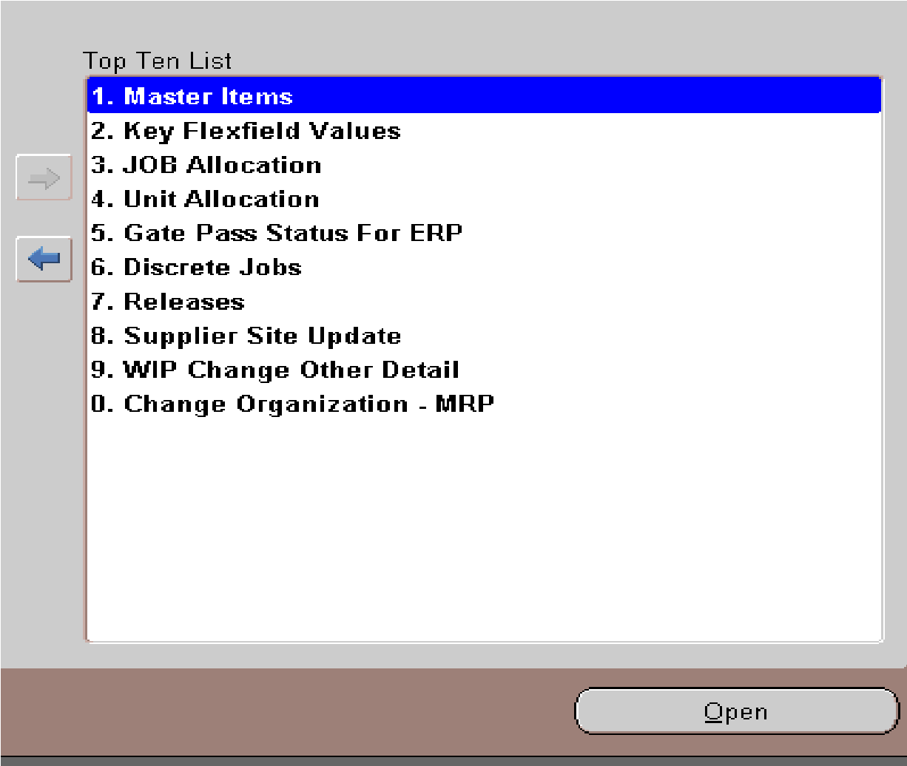

1.User detail for Fixed Assets-(0100) code opening
Item : Unique item number.
Description : UNLOADING VALVE KIT [2901-1101-00] [T7200F... ]
UOM: Packet
COMBINATION : 0100-0001-0002-0008
S.NO : KIT
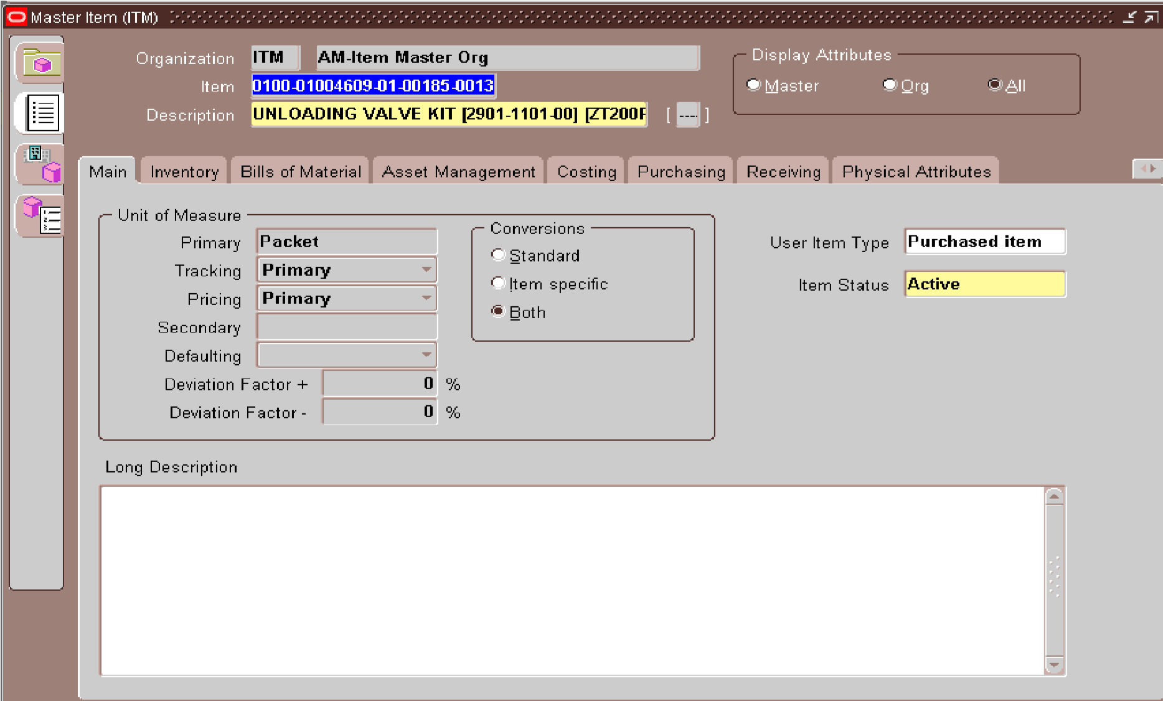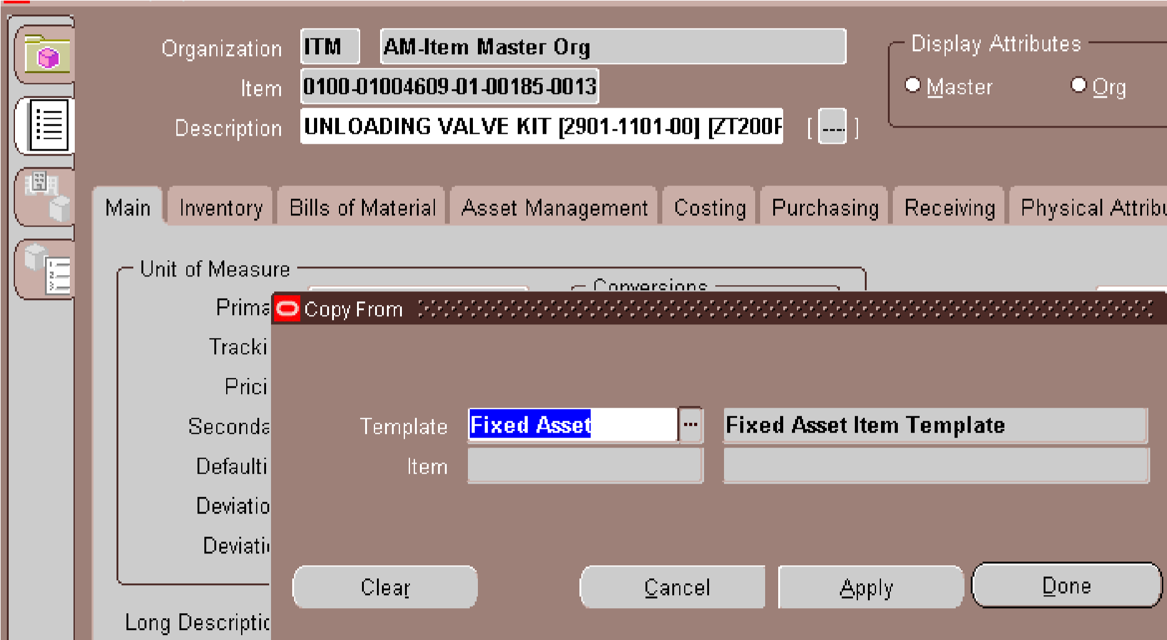
UNIT :
AM4
ALT+T+C FOR OPEN TEMPLATE FORM
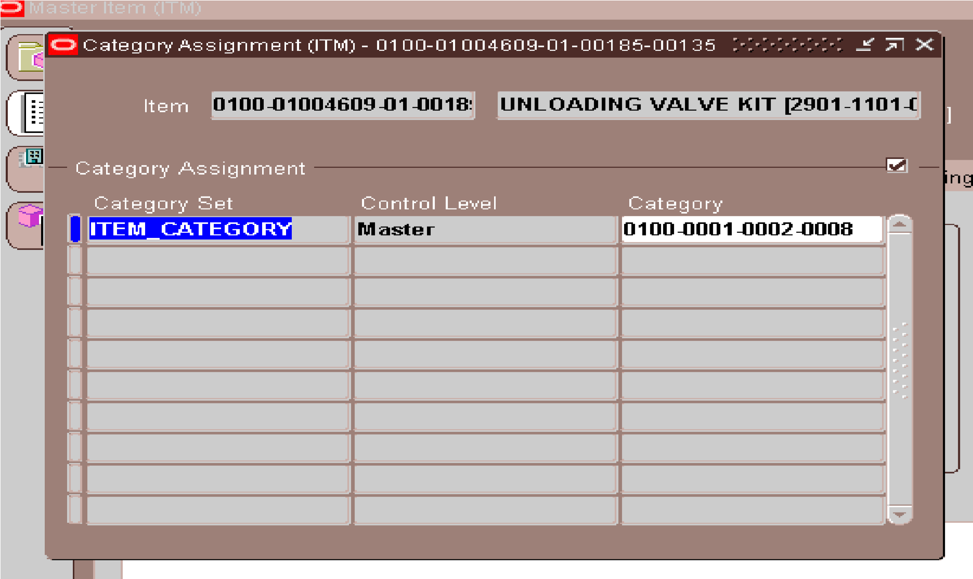
ALT+T+A FOR OPEN CATEGORY FORM
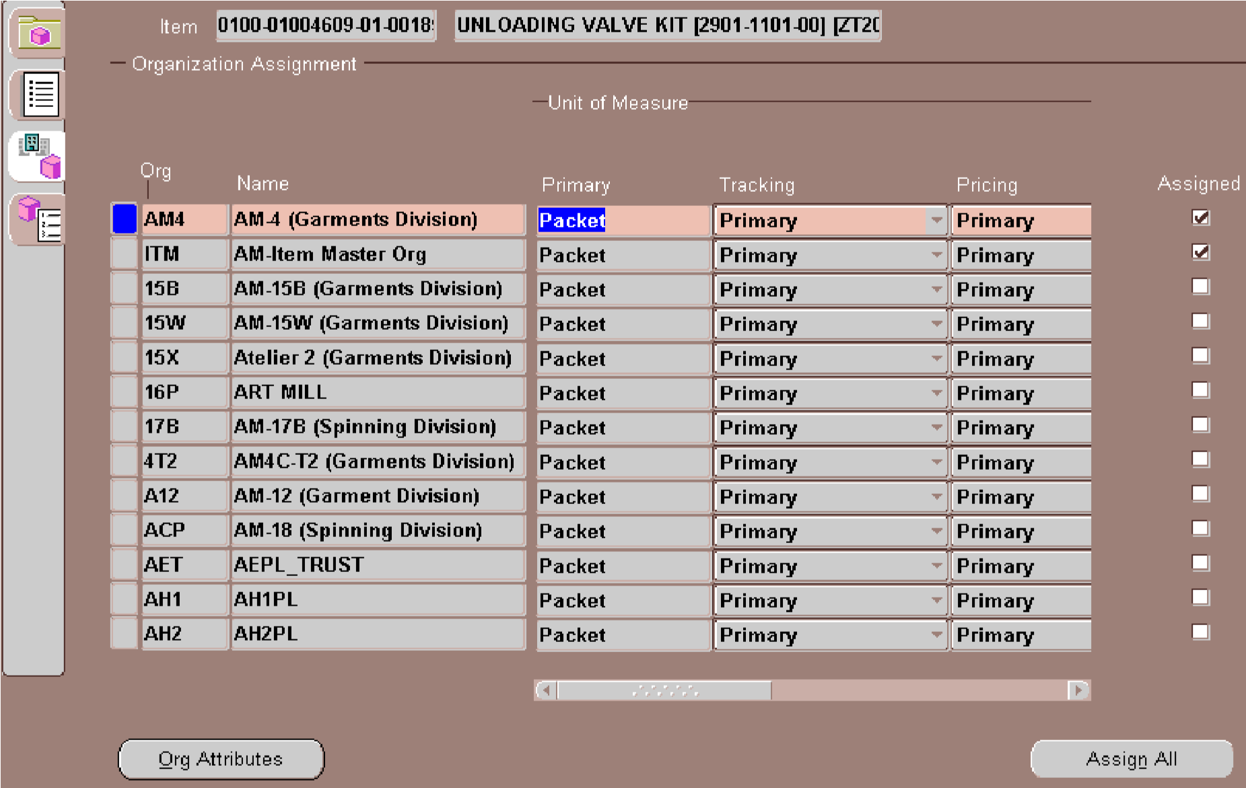
ALT+T +O FOR ASSIGN IN THE UNITS … THEN ALT+T+U FOR ITEM SUB-INVENTORIES X____________________________________________________________________________x

2.User detail for Store & spare-(0200) code opening
ITEM CODE :
BB-2MS-RCBO-18G-MS-PC DESCRIPTION :
BACK BOX, TWO MULTI SHEET & RCBO, 18 GAUGE, POWDER COATED, MS ITEM TYPE :
BACK BOX
SIZE :
18 GAUGE
( I AM NOT USING GAUGE AS AN ACTUAL SIZE BECAUSE ITS MEAN IS THICKNESS NOT LENGTH, WIDTH OR DEPTH ) ITEM COLOR :
POWDER COATED [M.S]
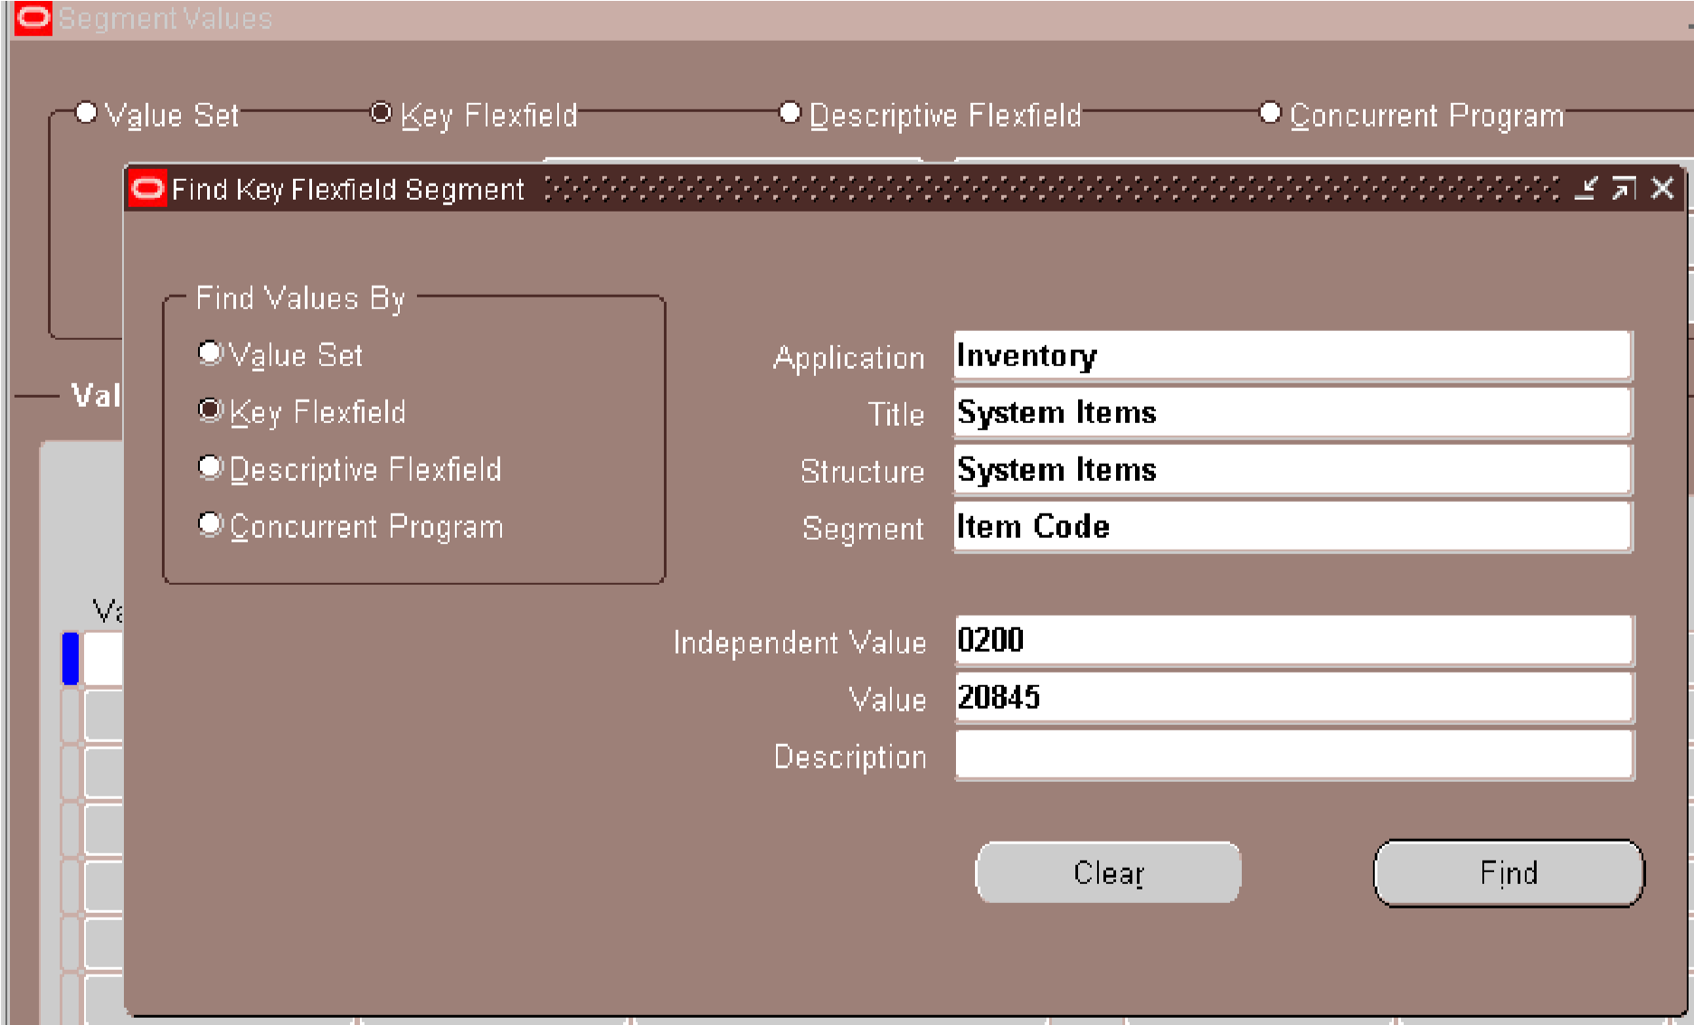
WHEN ITEM SIZE OR CODE NOT FOUND OPEN IT IN KEY FLEXFIELD
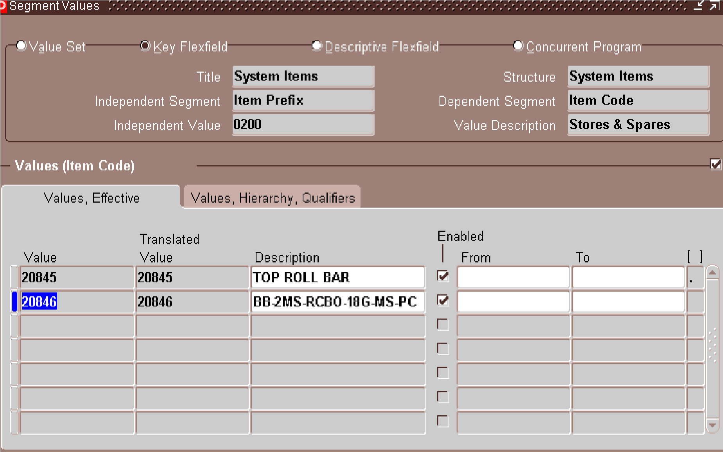
SHIFT+F5 FOR VALUE CHANGE THE LAST SERIES OF NUMBER AND COPY DESCRIPTION GIVEN BY USER
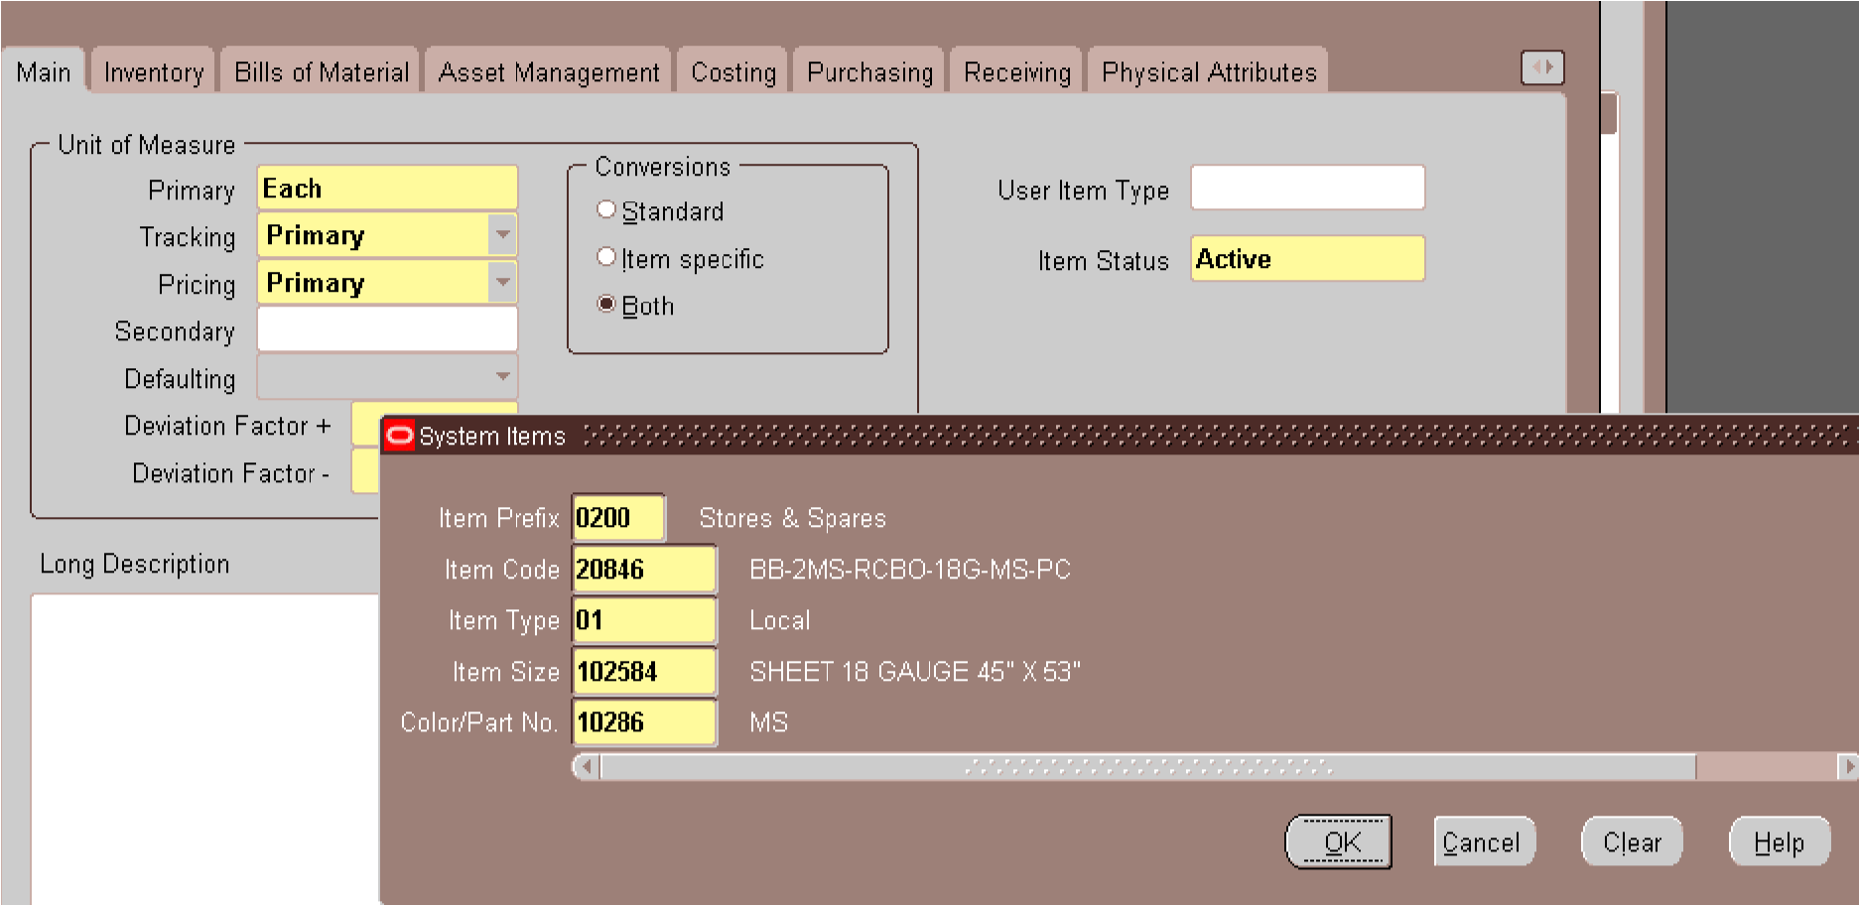
0200 IN ITEM CODE AND THEN CTRL+L FOR SYSREM ITEMS
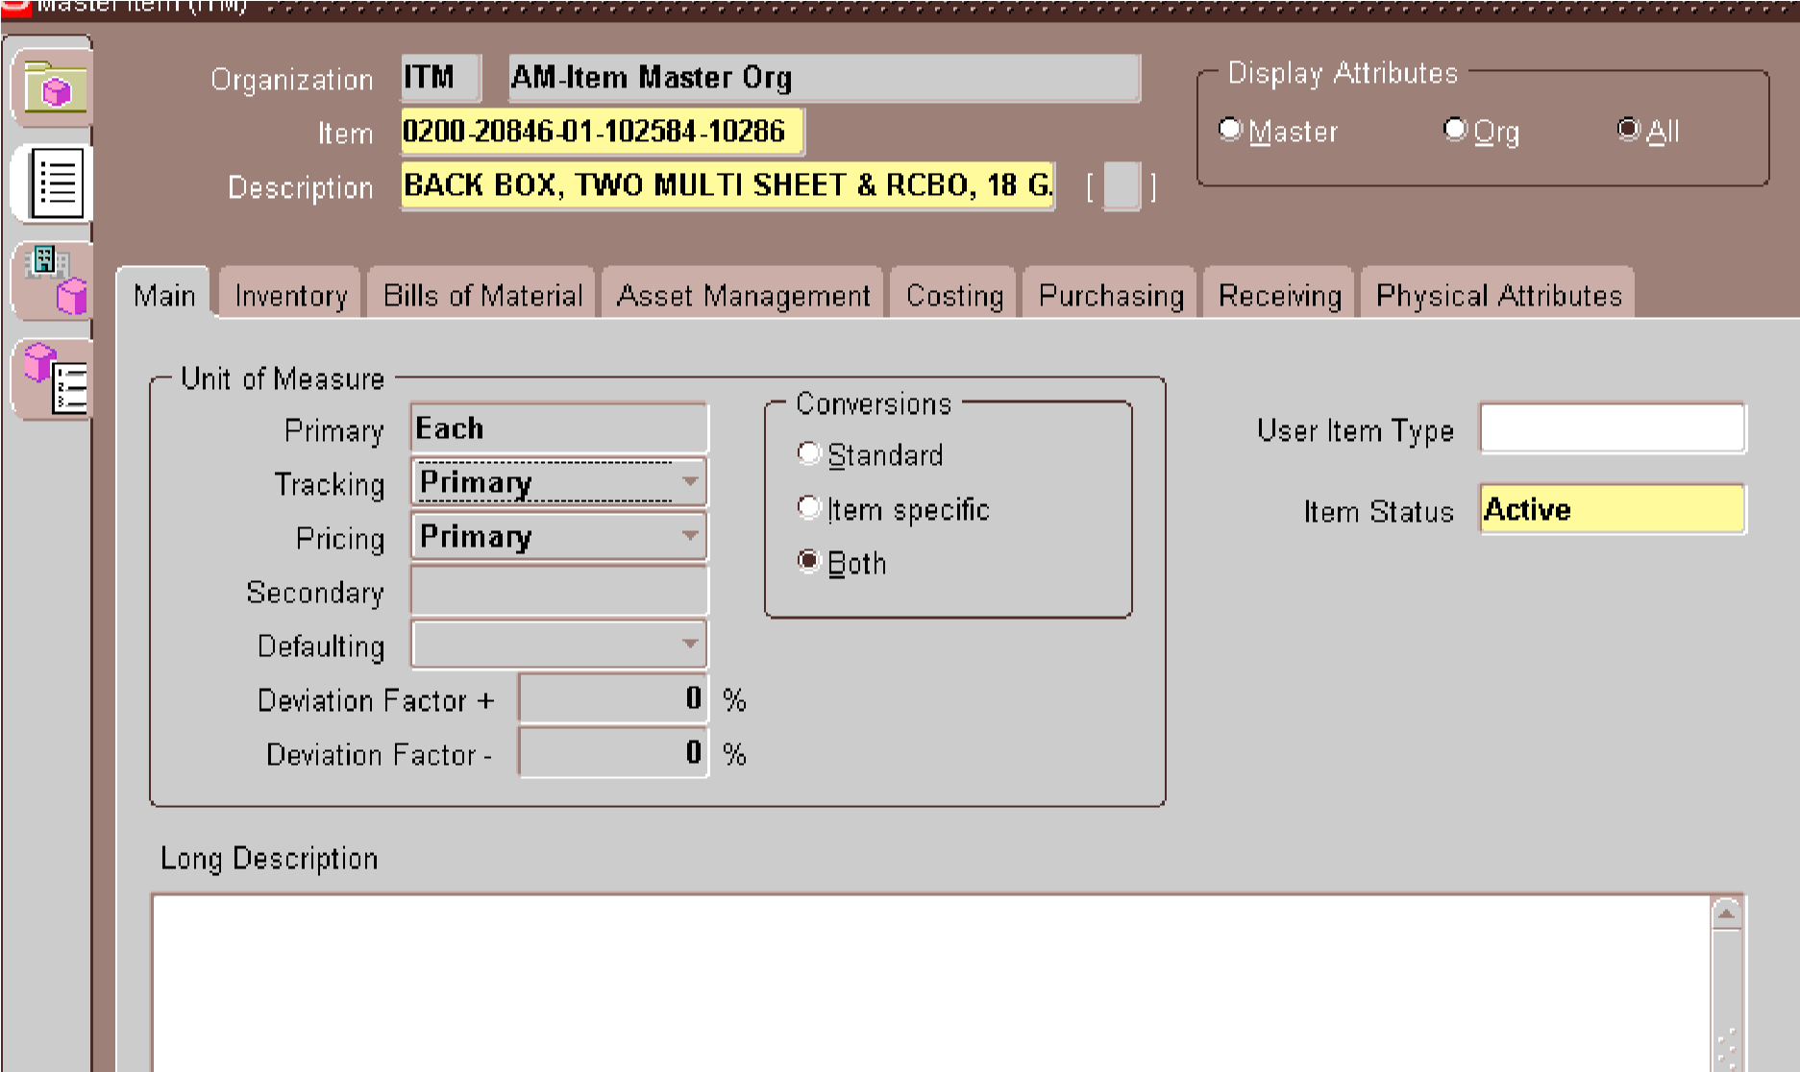
COPY THE DESCRIPTION GIVEN BY USER
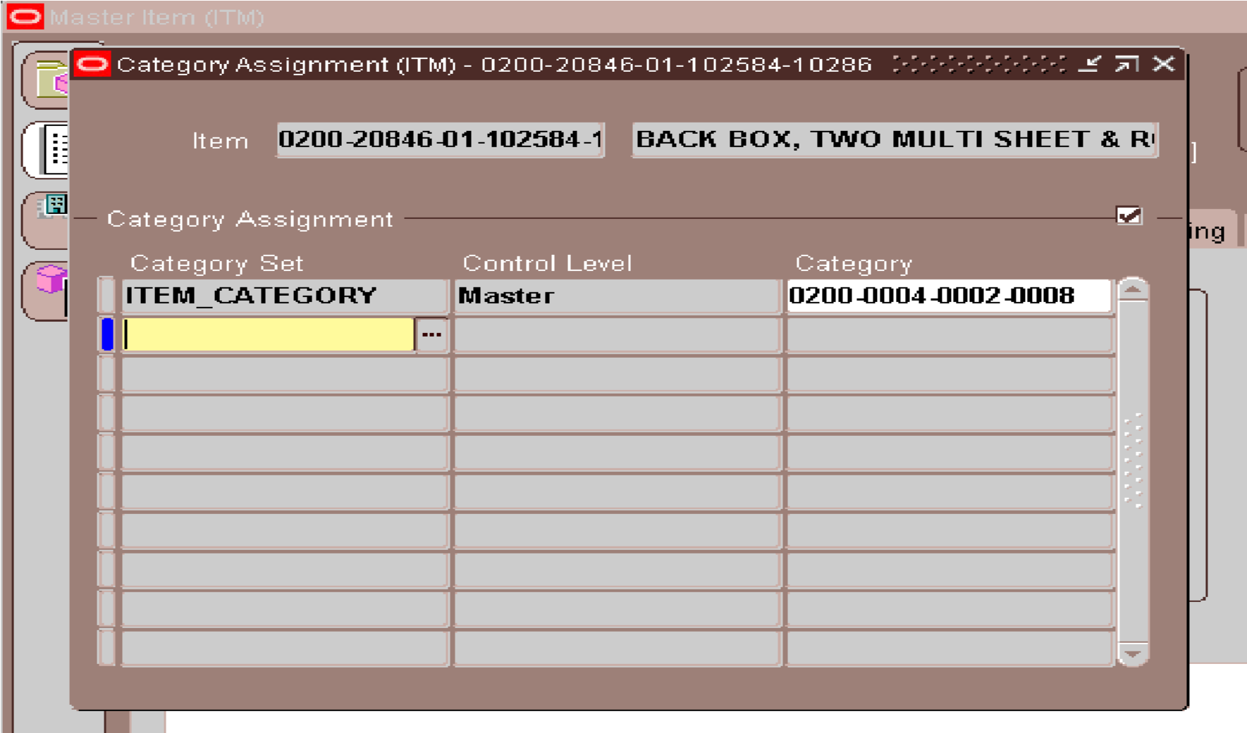
ALT+T+A FOR OPEN CATEGORY FORM
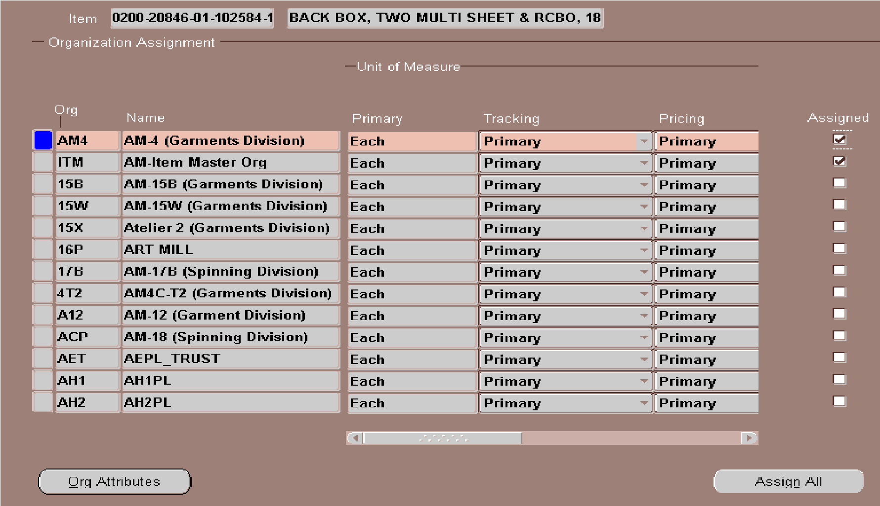
ALT+T+O FOR ASSIGN IN THE UNITS … THEN ALT+T+U FOR ITEM SUB-INVENTORIES THE LOCAL ITEM WILL ONLY APPLY IN AM4 & AMG.
THE IMPORT ITEM WILL APPLY IN AM4, AMG & BWH.
X__________________________________________________________________________X

3.User detail for DYE & CHEMICAL -(0300) code opening
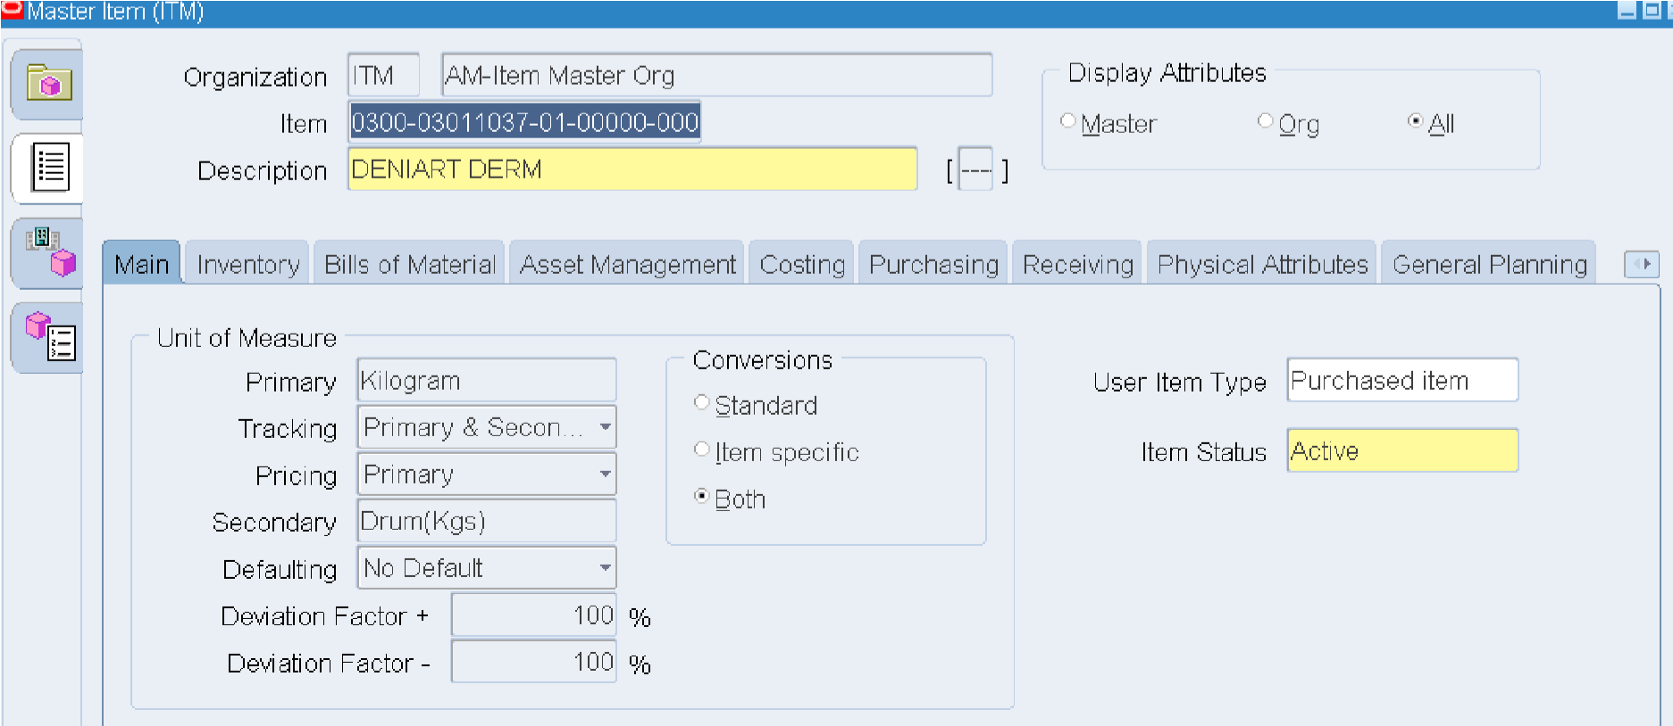
0300 IS THE ITEM CODE .. AND UOM ARE SAME IN EACH DYE & CHEMICAL CODE AS ABOVE SHOWN IN PICTURE
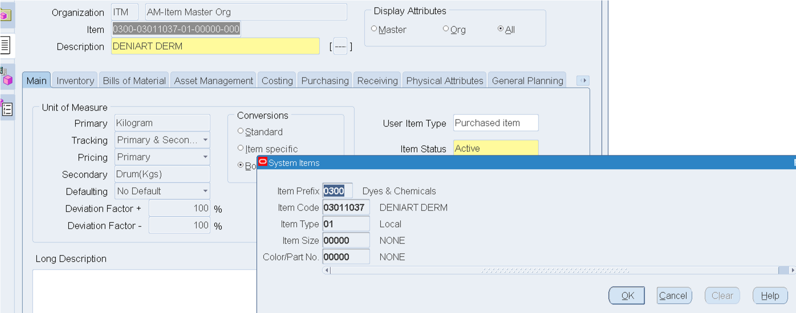
ALT+T+C FOR OPEN TEMPLATE FORM
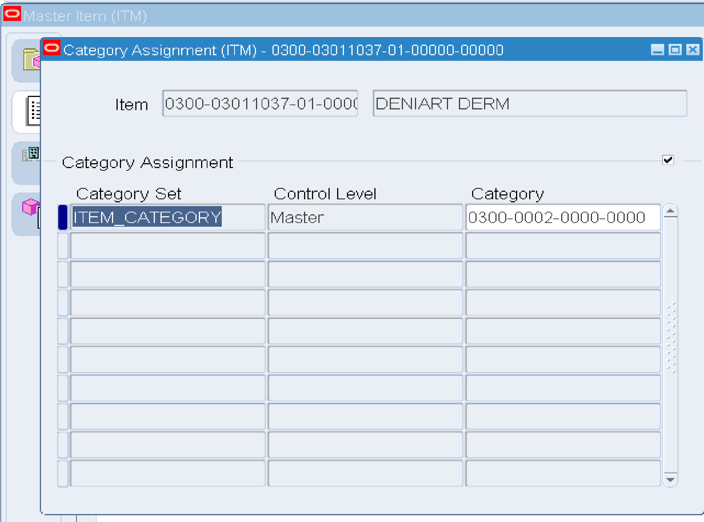
ALT+T+A FOR CATEGORY PUT 0300 AND THEN TAB
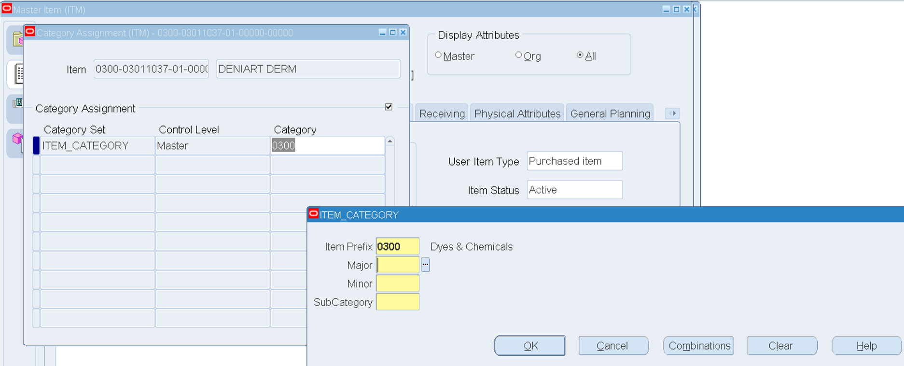
ALT+M FOR COMBINATIONS
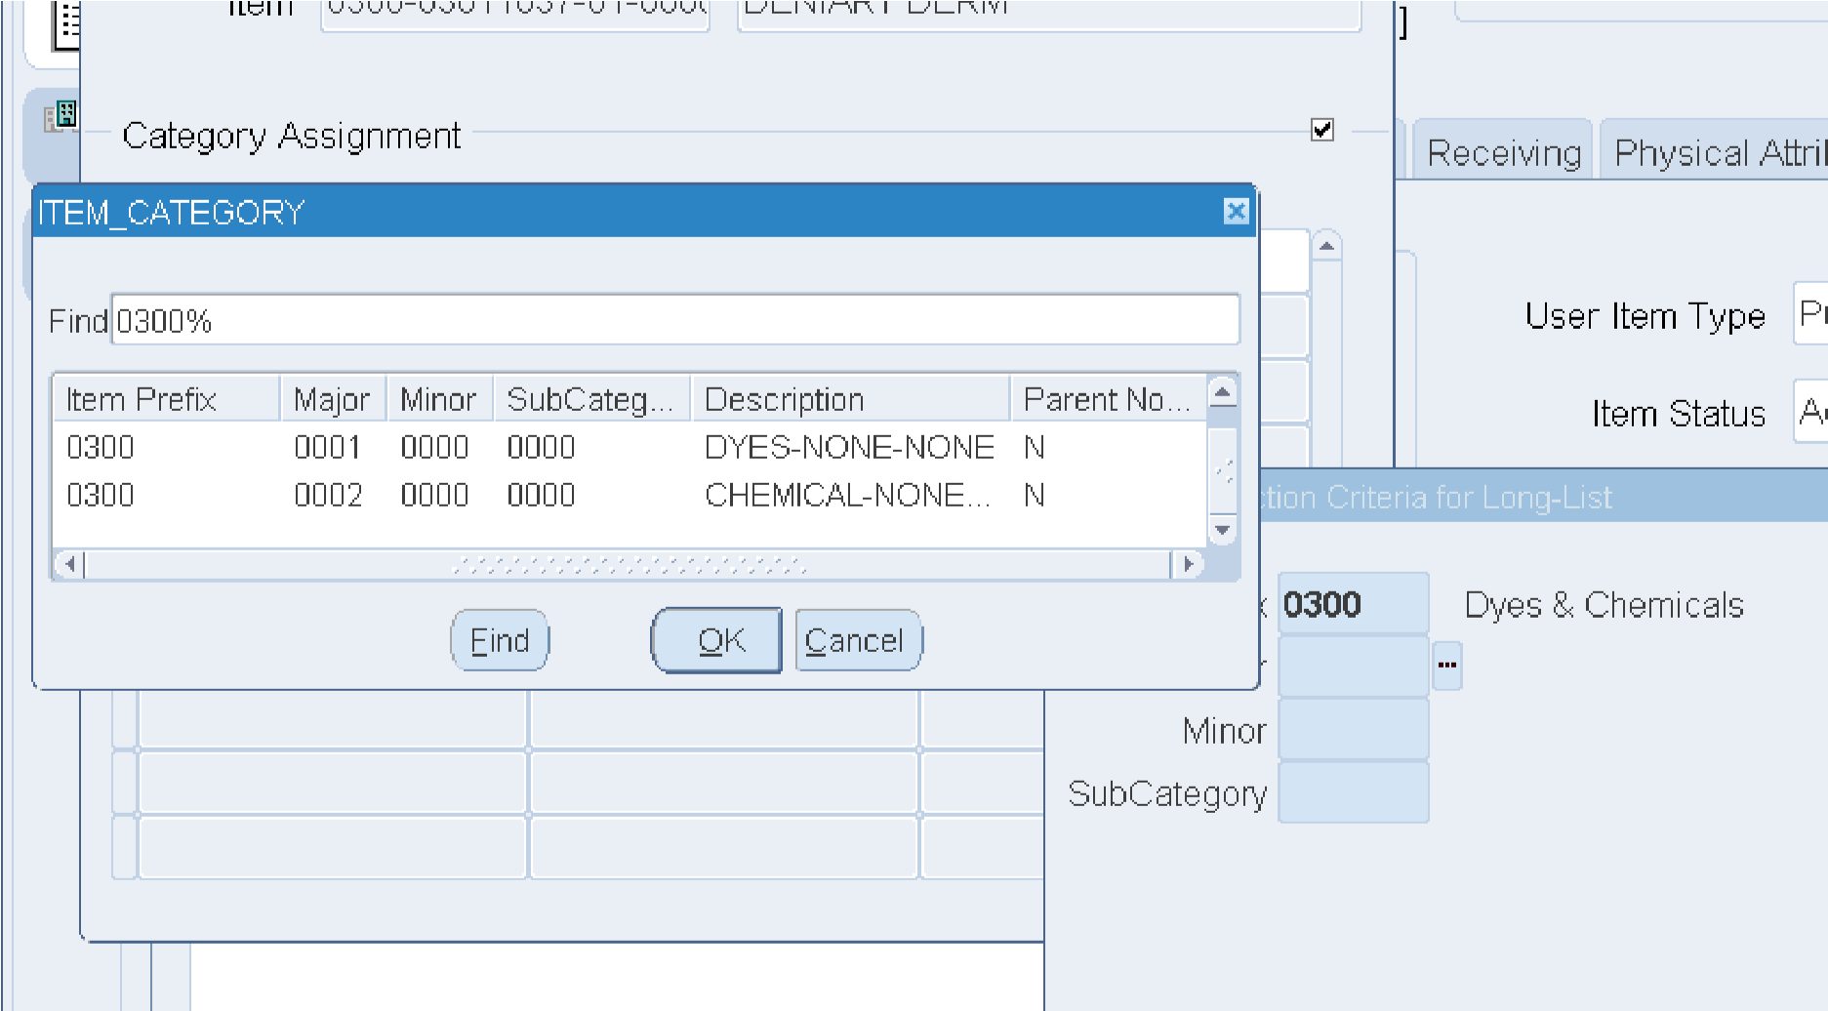
SELECT CATEGORY GIVEN BY USER WHETHER ITS DYE OR CHEMICAL
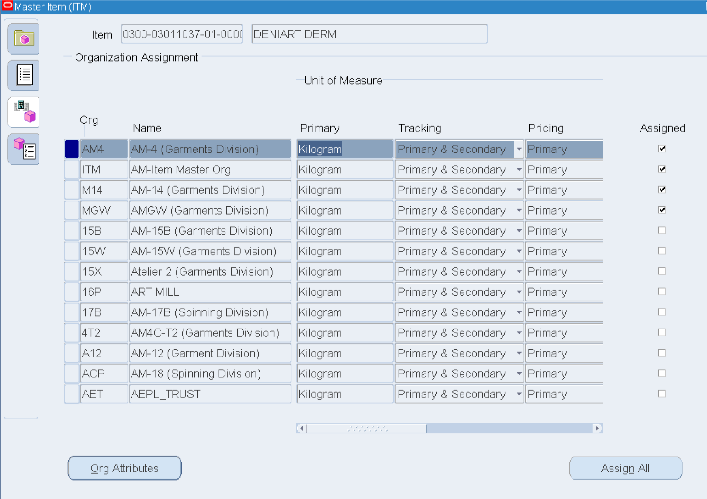
ALT+T+O FOR ORGANIZATION .. ASSIGN IN AM4 & AMG IN LOCAL.
ASSIGN IN AM4, AMG & BWH IN IMPORTED.
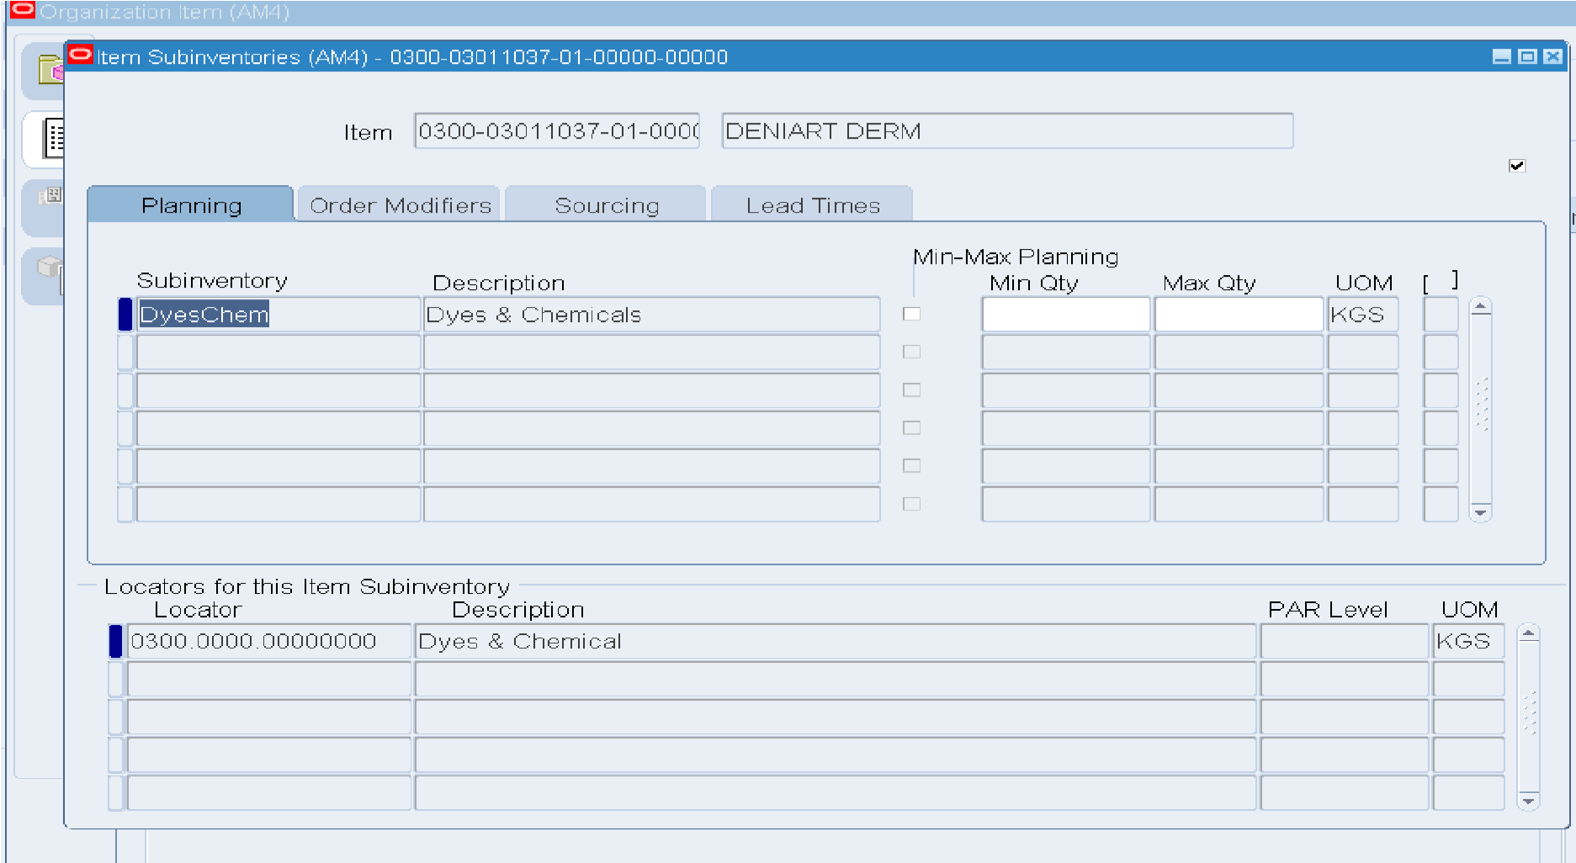
ALT+T+U FOR ITEM SUB-INVENTORY
X__________________________________________________________________________X

4.User detail for FABRIC-(0500) code opening
DESCRIPTION :
AGI-20641-B/A3
COMPOSITION :
70 % Cotton, 20% PIW Cotton, 9% Recycled Poly, 1% Elastane
CATEGORY :
DENIM
SOURCE :
LOCAL
WEIGHT(OZ) :
11.00 OZ
WIDTH :
64
UOM :
MTR (METER)
LEAD TIME :
45
CERTIFICATION :
GRS
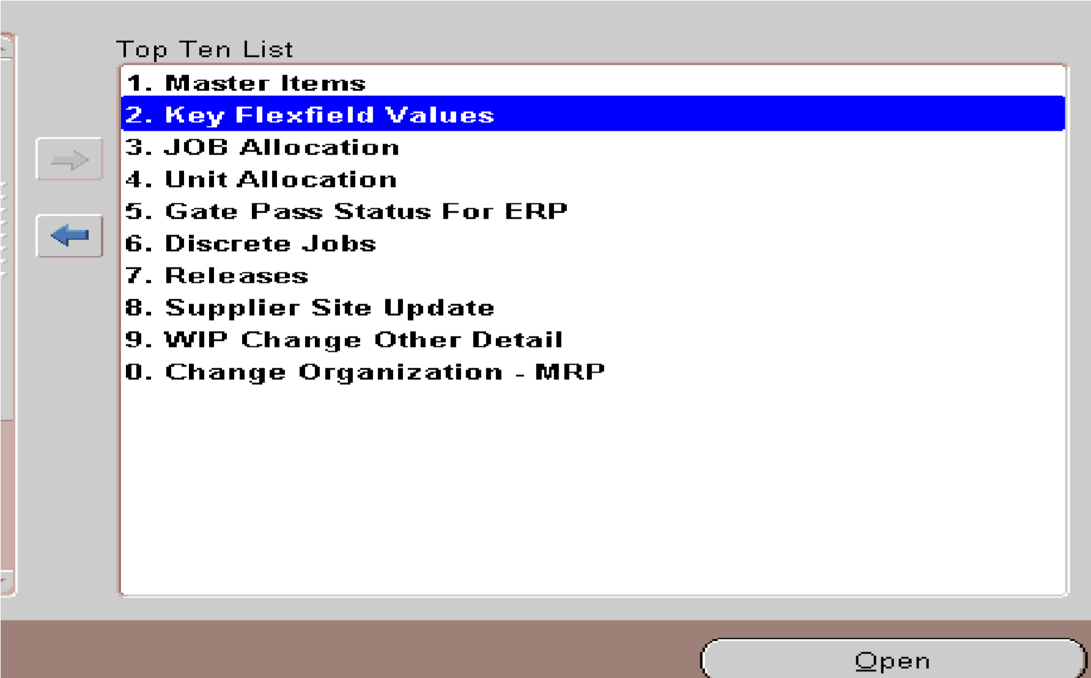
We normally access the Master Items section; however, since the item code was not provided, we used Key Flexfield Values to create a new item code.
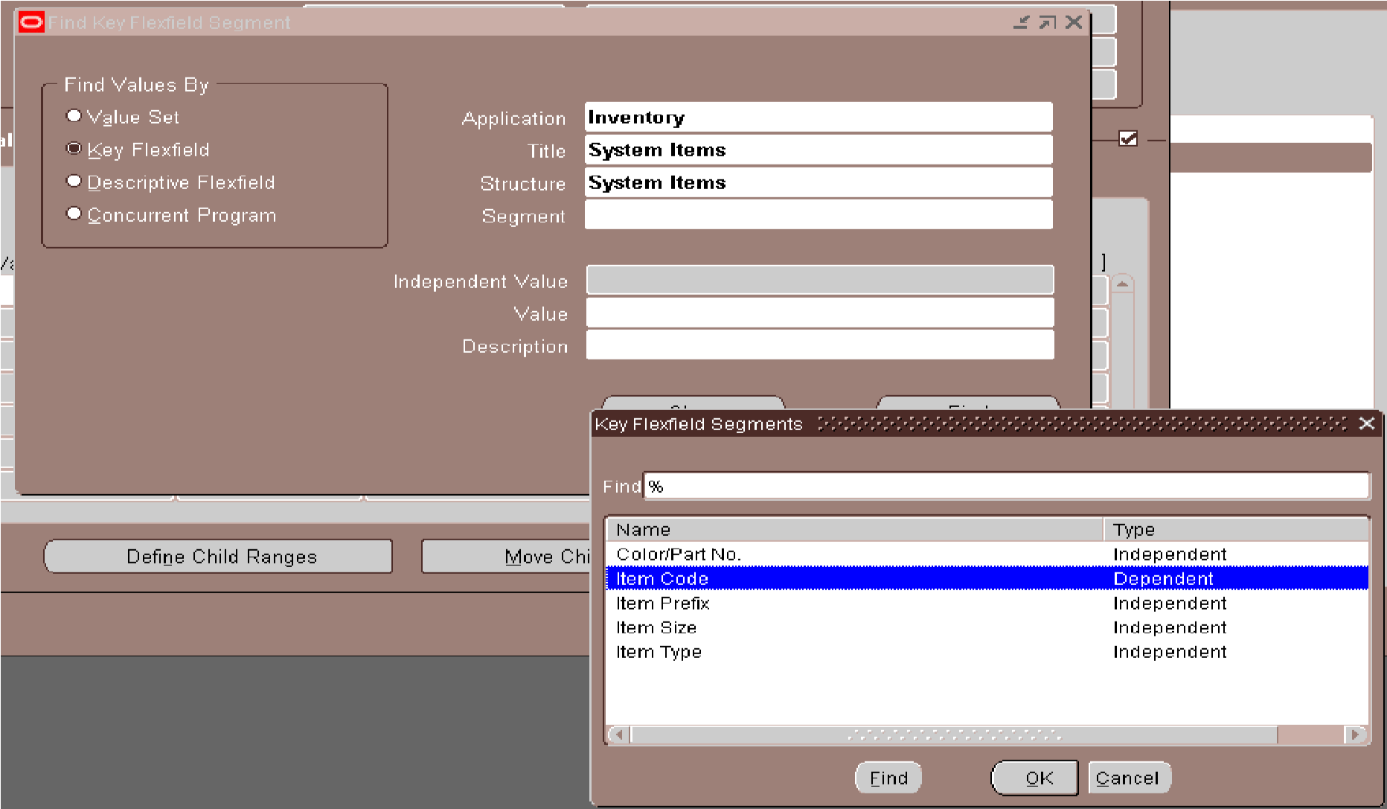
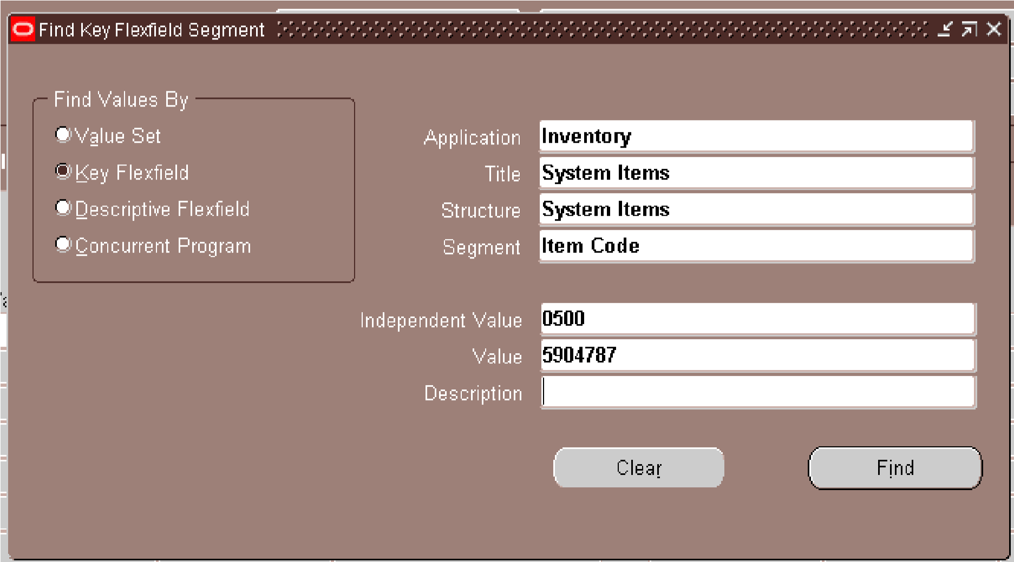
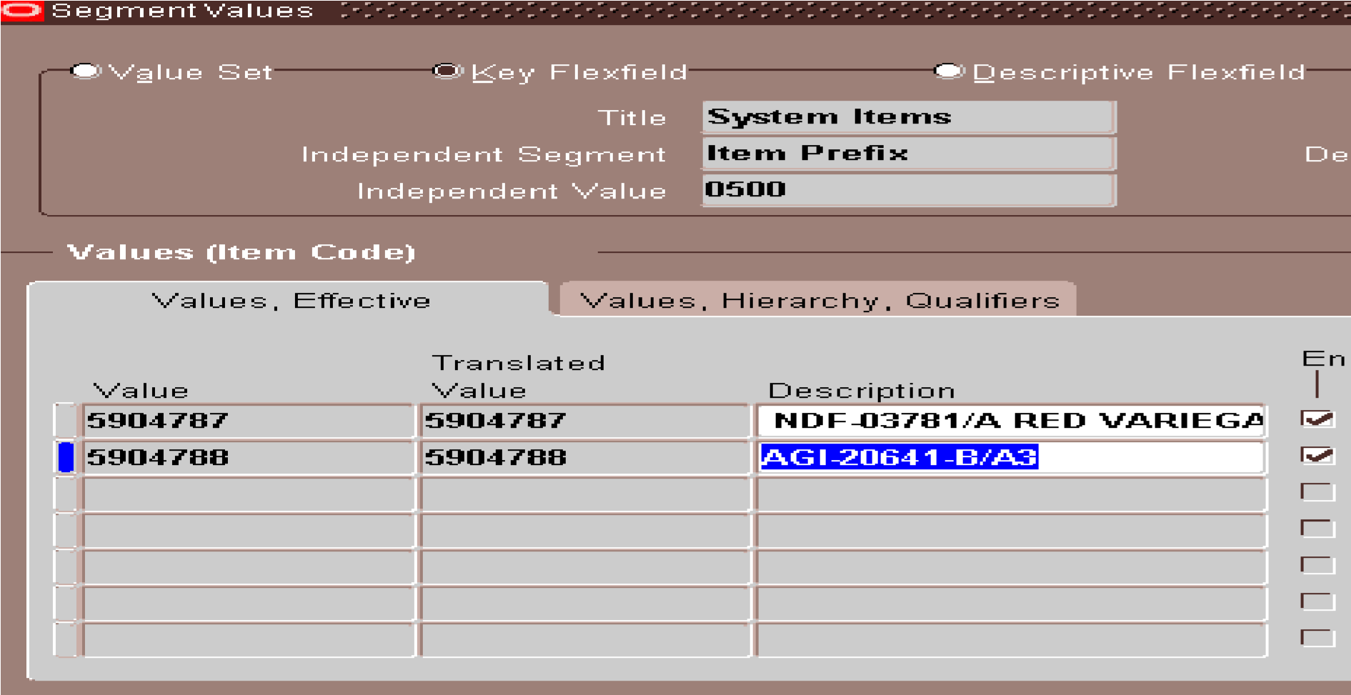
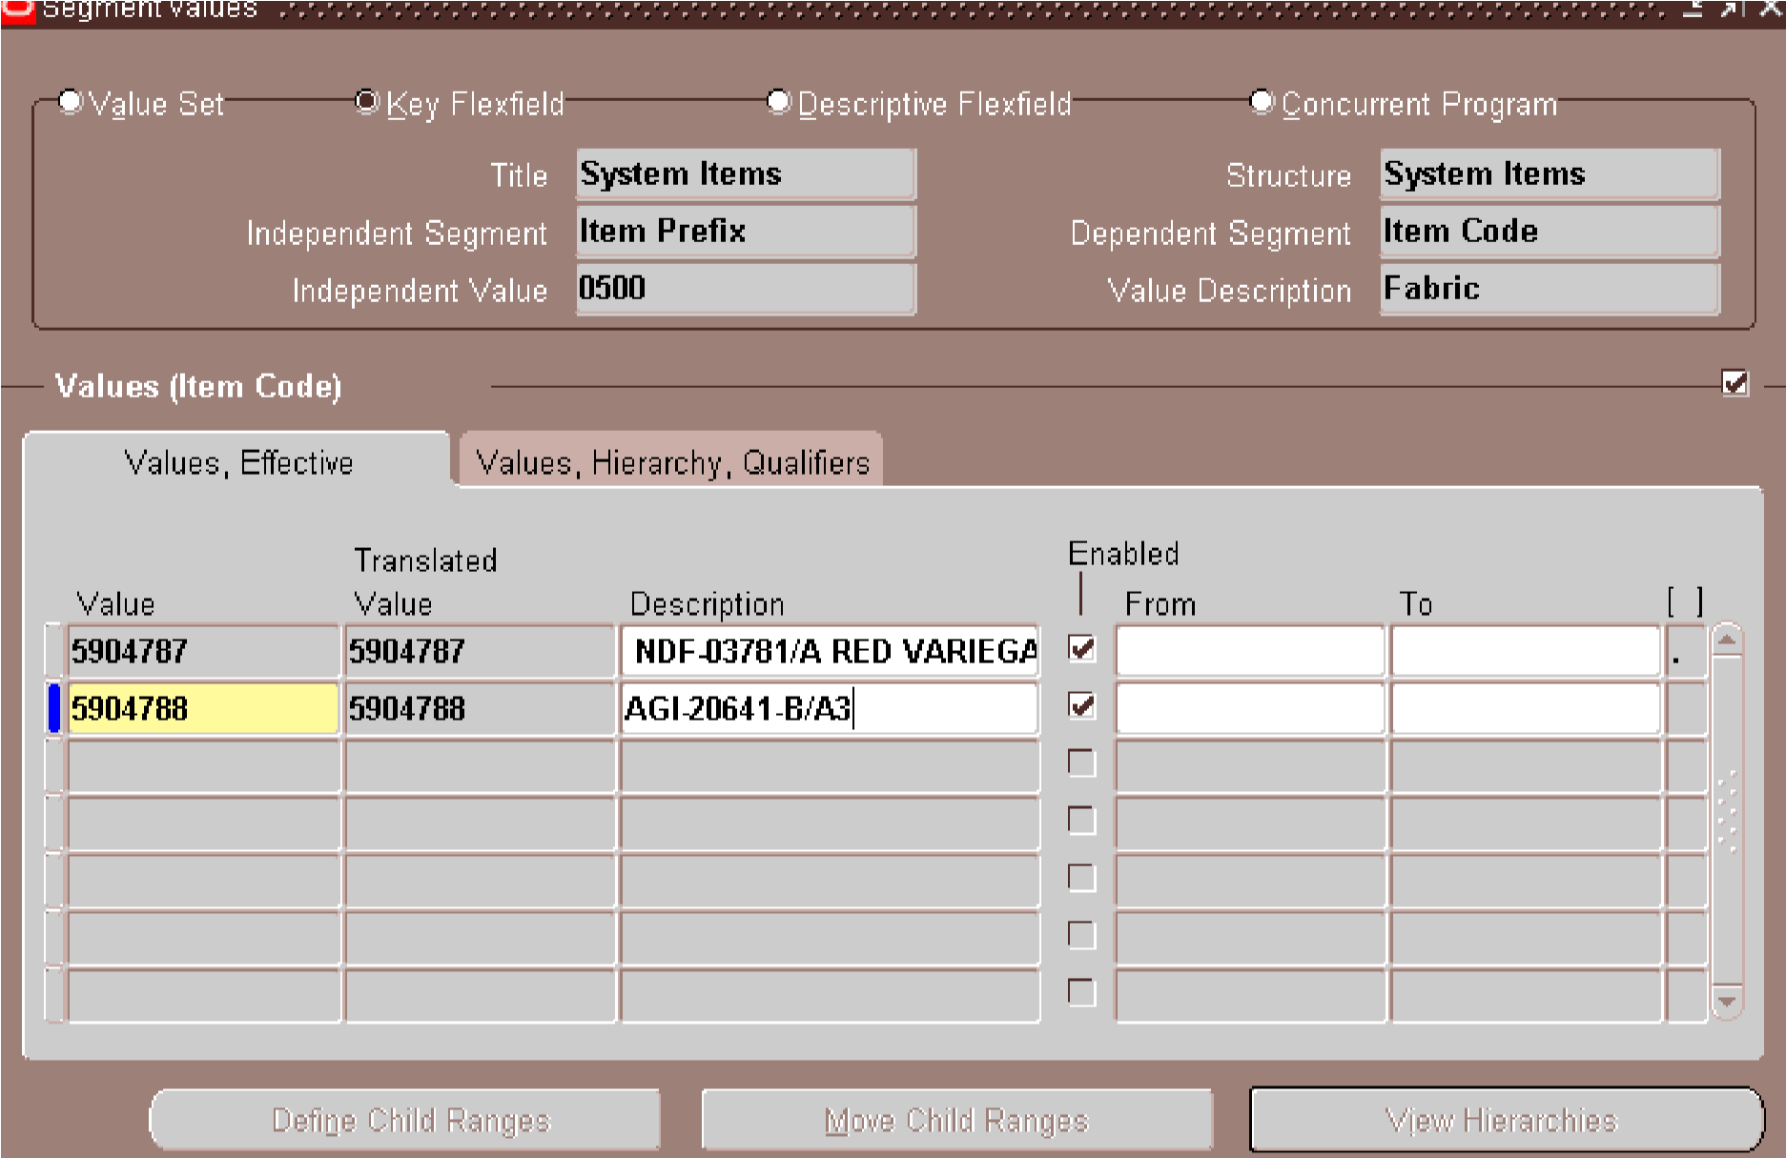
Form: Master Item
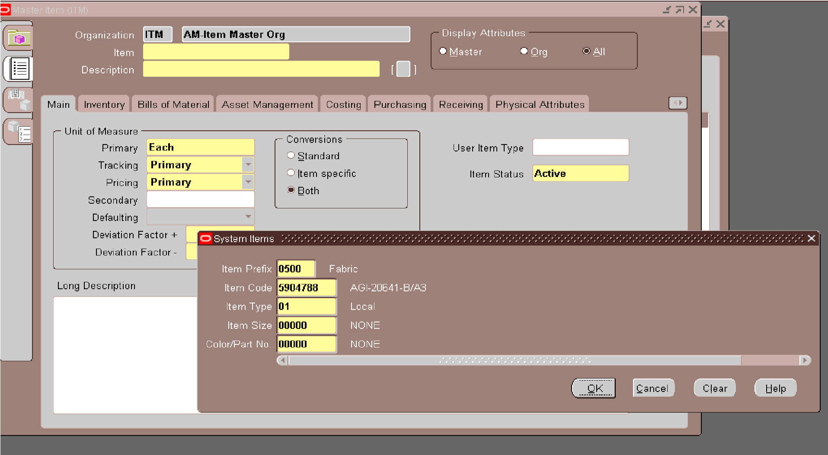
If you have found the code during your search, select that code, or choose the one you have opened. This will help ensure accuracy in your selection
- Item Prefix: Choose the pre-defined prefix.
- Code: Select as required: the existing option or the new one.
- Type: Understand the type of the item (e.g., local, import.).
- Size: Select as required: the existing option or the new one
- Color/Part Number: Select as required: the existing option or the new one
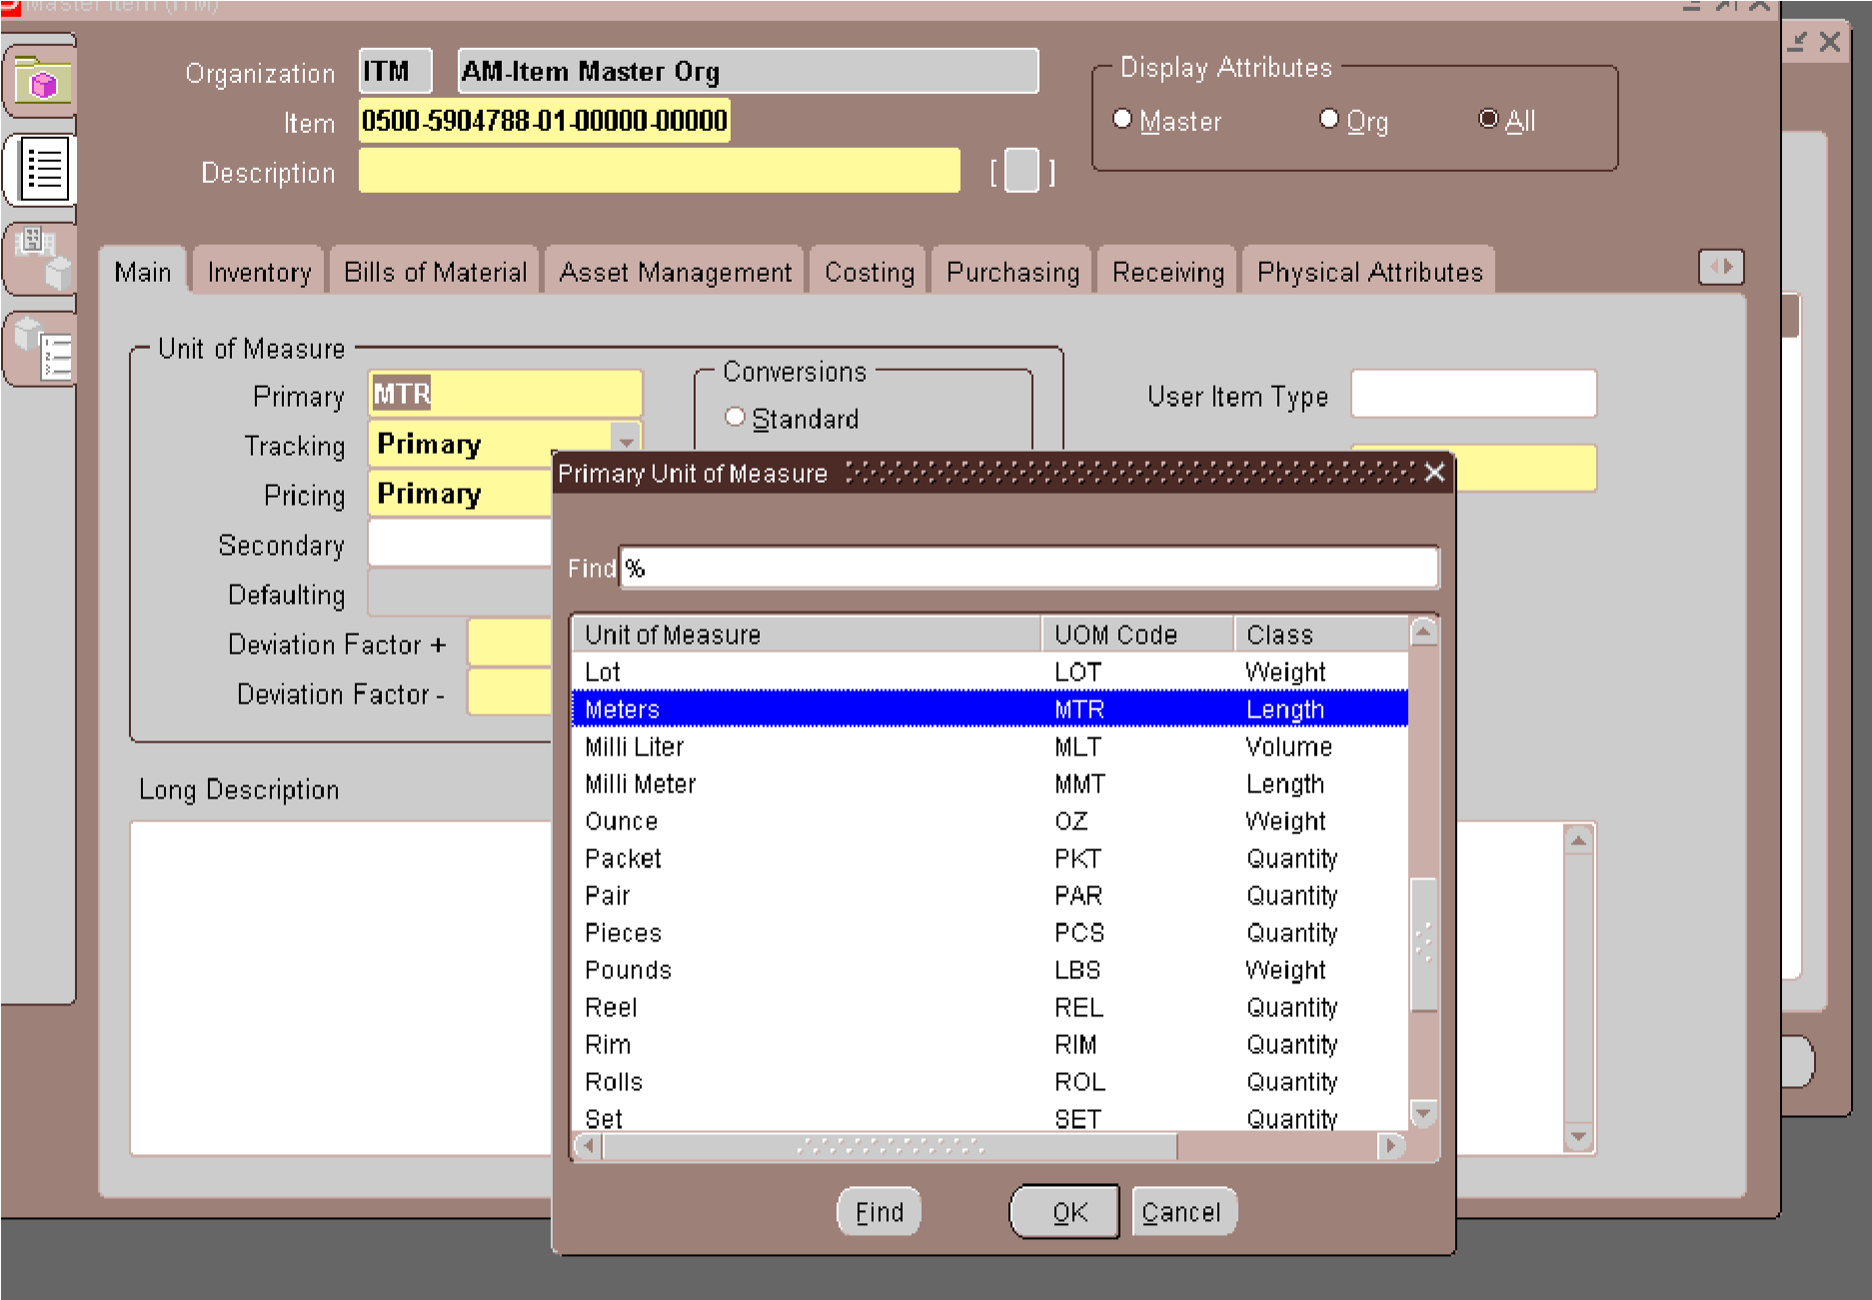
Enter the description, select the unit of measure (UOM).
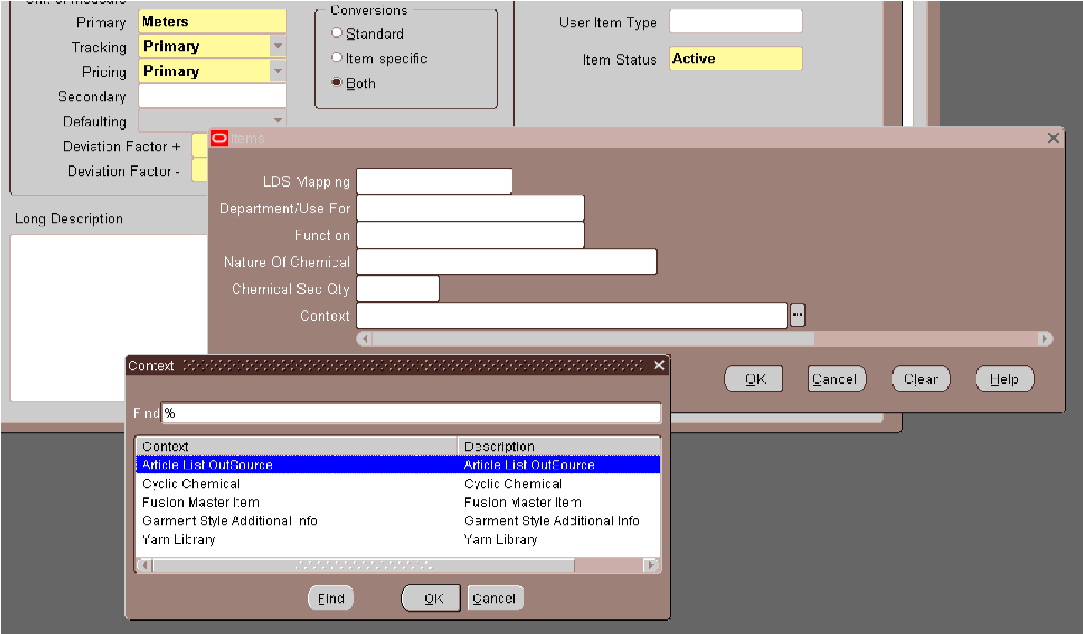
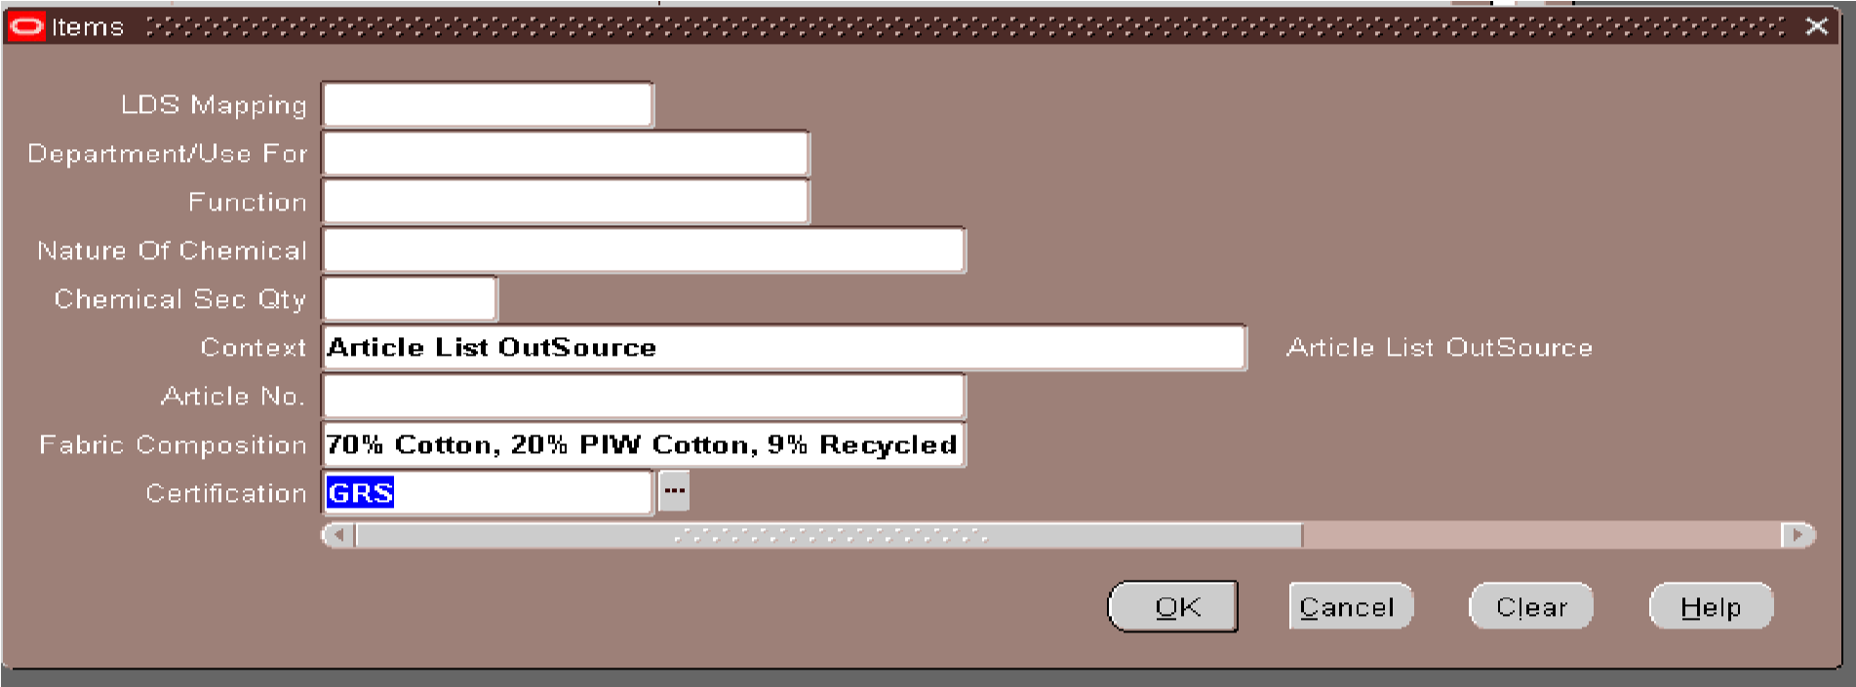
This screen is used to select the appropriate Context for the item. We select the required context, such as Fusion Master Item, to enter the relevant item information.
This screen is used to enter the item-specific details, such as Article Number, Fabric
Composition, and Certification, under the selected context
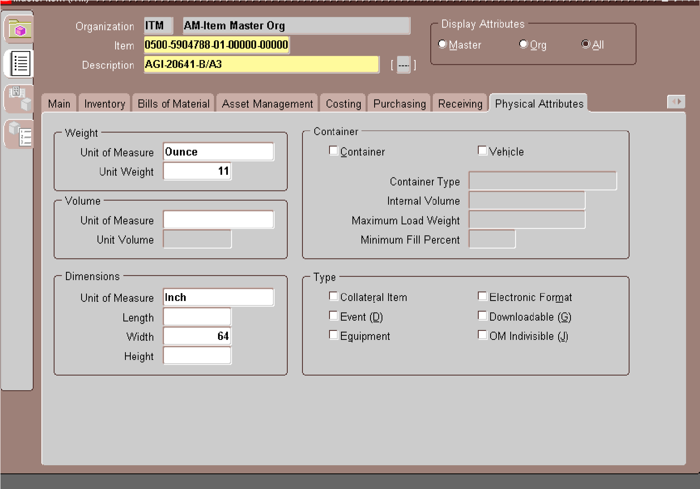
This screen is the Physical Attributes section in Oracle EBS Item Master. It is used to define the physical details of an item.
- Weight: Enter the item weight and select the UOM (e.g., Ounce).
- Dimensions: Enter Length, Width, and Height with the UOM (e.g., Inch).
- Container: Select if the item is a container and enter container-related details.
- Type: Select whether the item is a Material, Equipment, or other applicable type.
- Lot/Serial: These options are used if the item needs lot or serial number tracking.
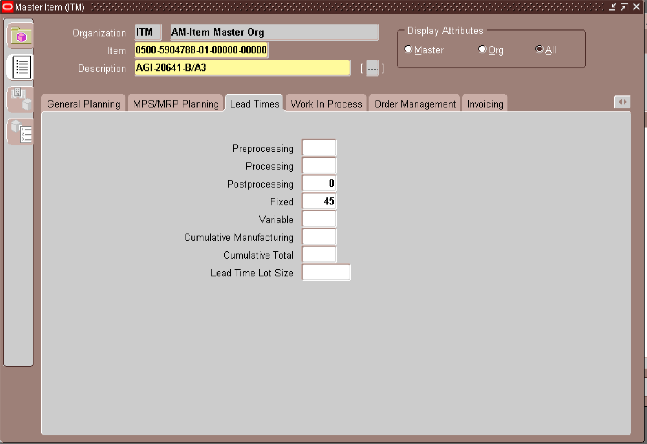
Go to the tools section, select the copy form, and apply the copy form/template according to the item prefix
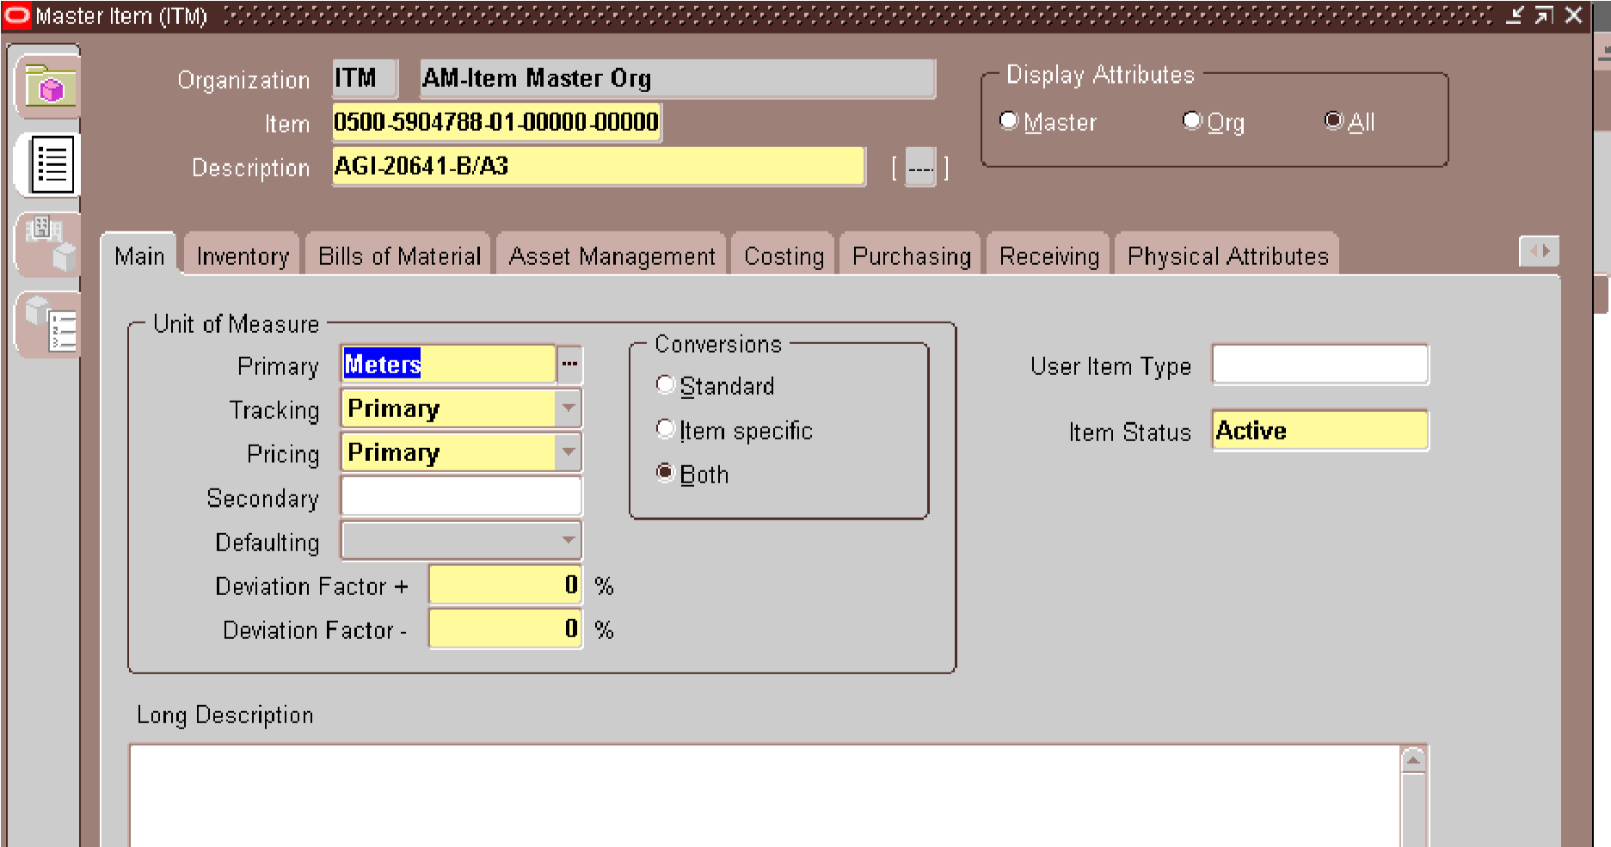
After entering all the required details, press Ctrl + S to save the item. This saves the Item Code,
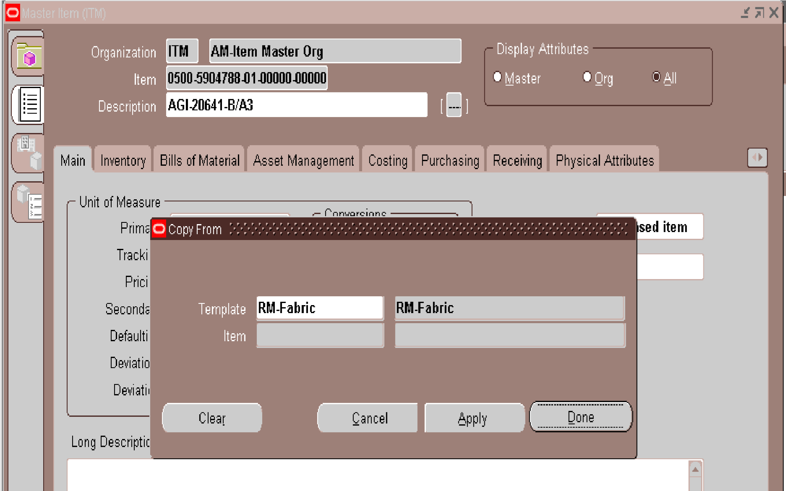
Description, and other entered information in Oracle EBS.
This is the

“Copy From”

window in Oracle Item Master.
Template:

Selects an existing item template, here

RM-Fabric
.
Item:

Shows the item/template information to copy from.
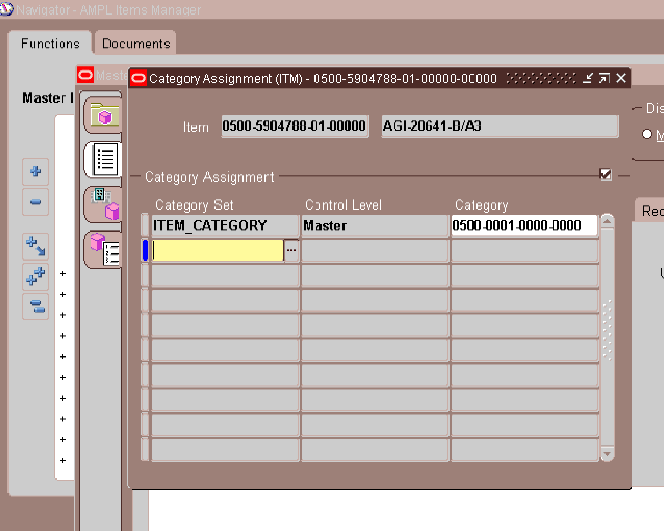
Apply:

Copies the selected template details to the current item.
Done:

Saves/closes the window.
Cancel:

Exits without applying changes.
To assign the item, simply tick the checkbox. For 0500 Fabric items,
assign the item to the required organizations, specifically

AM4 and
AMG. Then click

Save. After that, click on

Org Attributes

to maintain

the organization-specific attributes
If the item is imported, it will also be marked in BWH
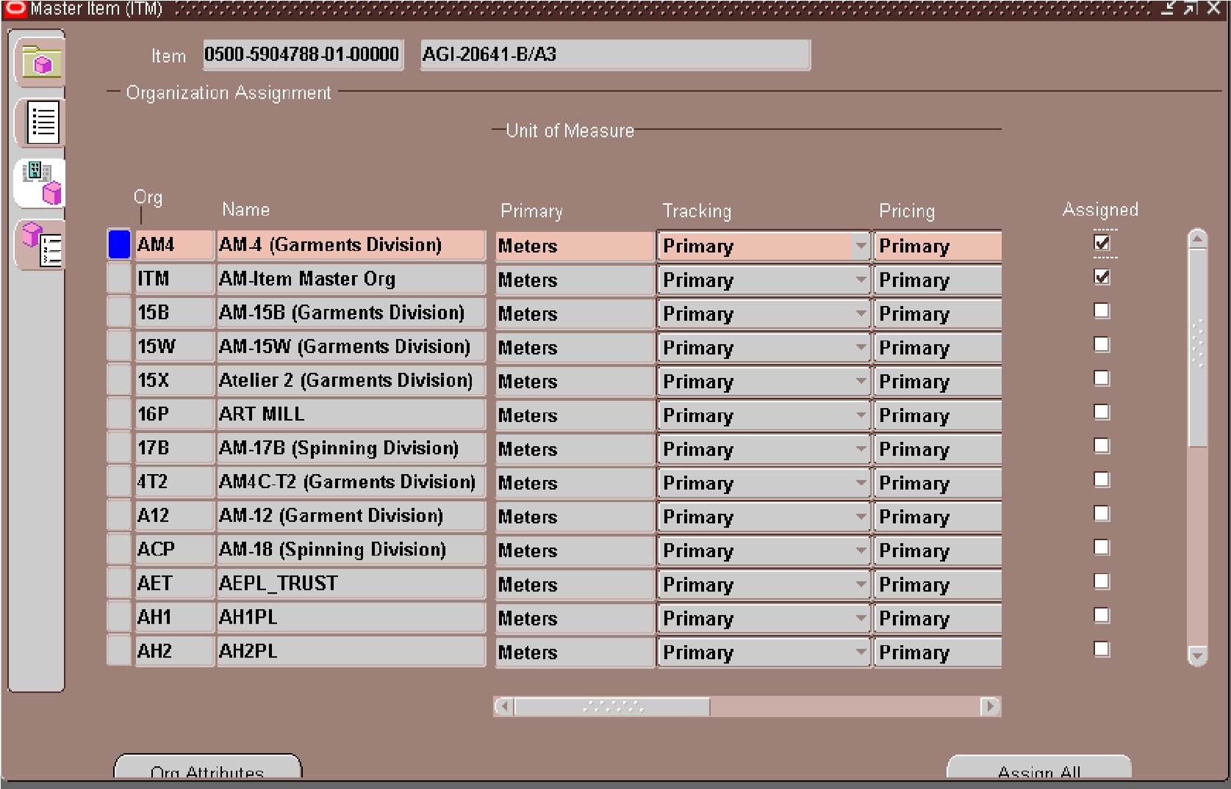
Go to the tool section and select ‘Item Sub inventory’
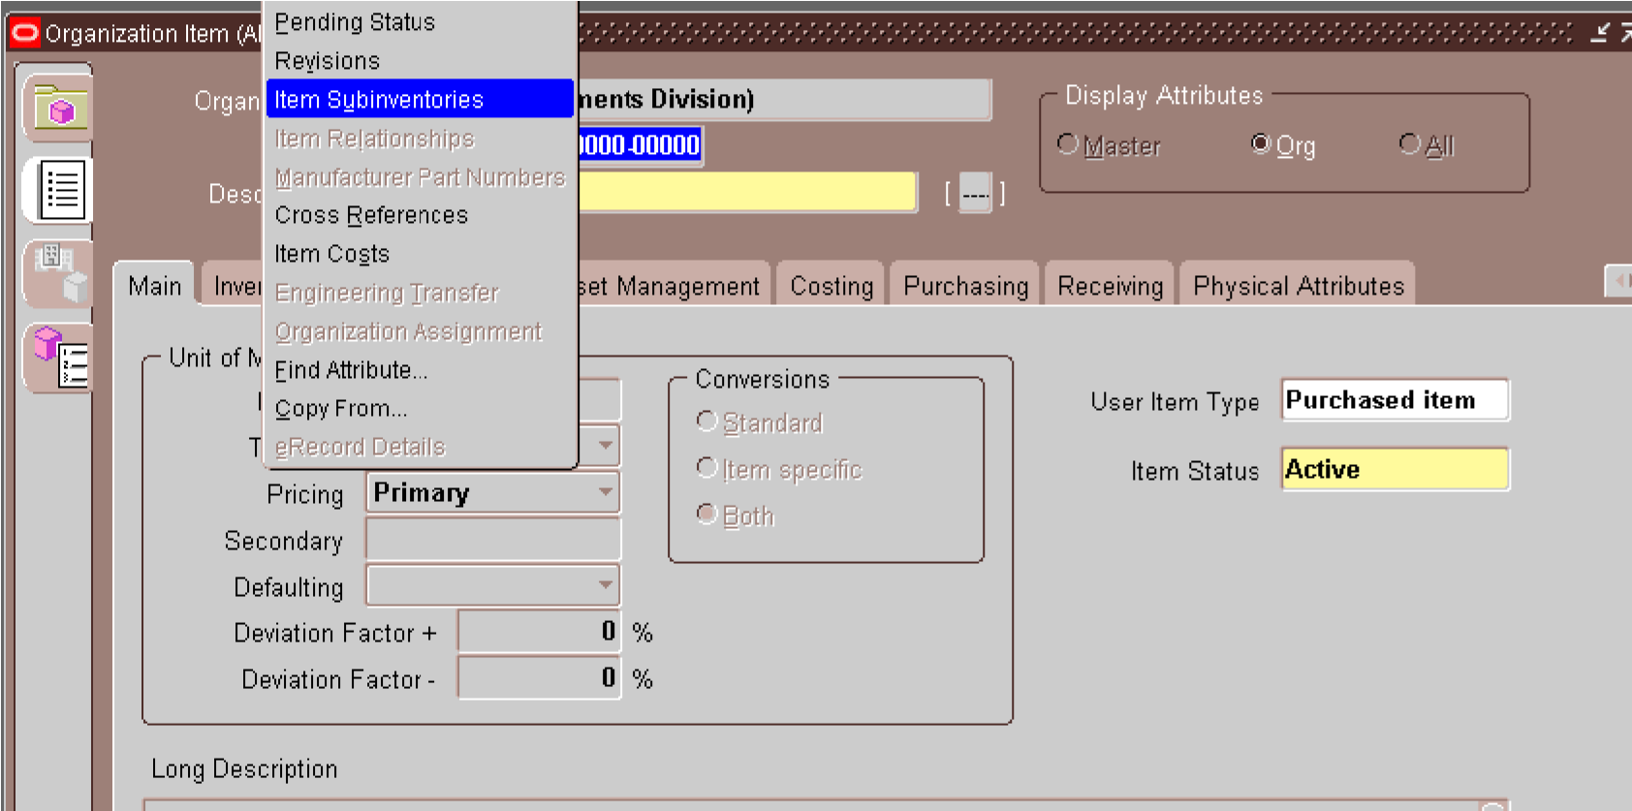
After that, mark the sub inventory and requested locator based on the prefix, and then save your changes
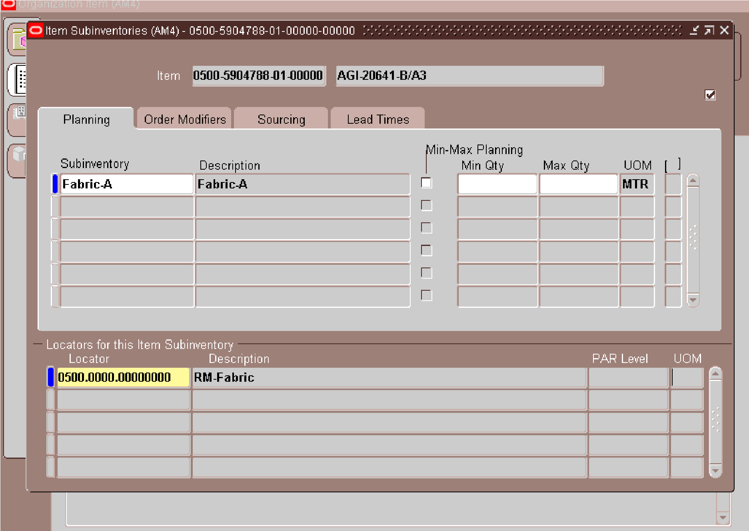
For prefix #0500 (Fabric), Subinventory and Locator are assigned instead of an Account, as shown in the screenshot.

X_______________________________________________________________________X

5.User detail for trims-(0900) code opening
Item Code: 0900-09000522-02-00170-2463
This is the unique identification/number assigned to the item in the ERP system. It is used to search for, track, purchase, receive, and manage this specific material.
Description: THREAD W-32449 TEX-80 [EPIC] [GAP] This describes the actual material:
THREAD : The item is a thread.
W-32449 : The thread's specific style/specification or internal reference.
TEX-80 : TEX 80, indicating the thread's linear density/thickness specification.
[EPIC] : Brand/type designation, likely referring to EPIC thread.
[GAP] An additional internal category/specification/location/group code used by the organization.
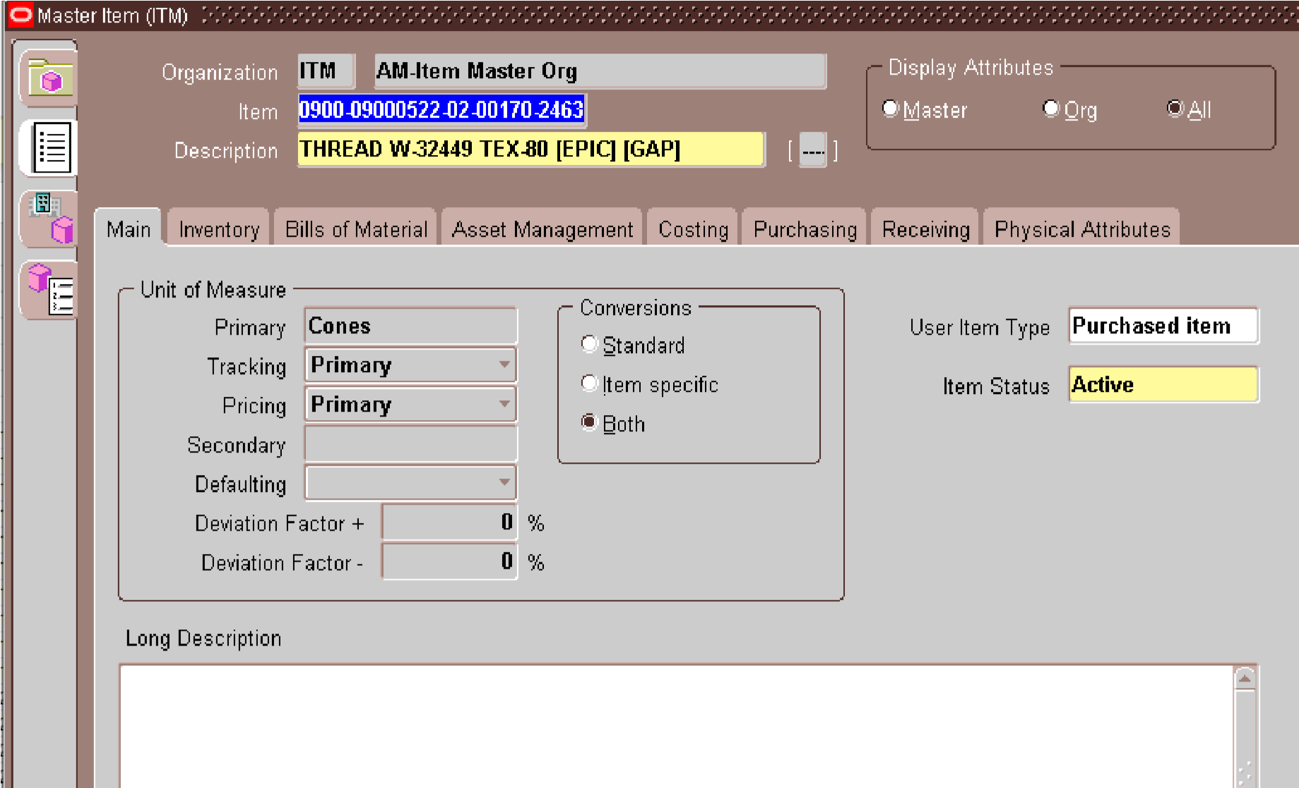
0900 FOR TRIMS IN ITEM NUMBER … CTRL+L FOR SYSTEM ITEMS AND THEN FILL ALL DETAILS GIVEN BY USER … PASTE DESCRIPTION
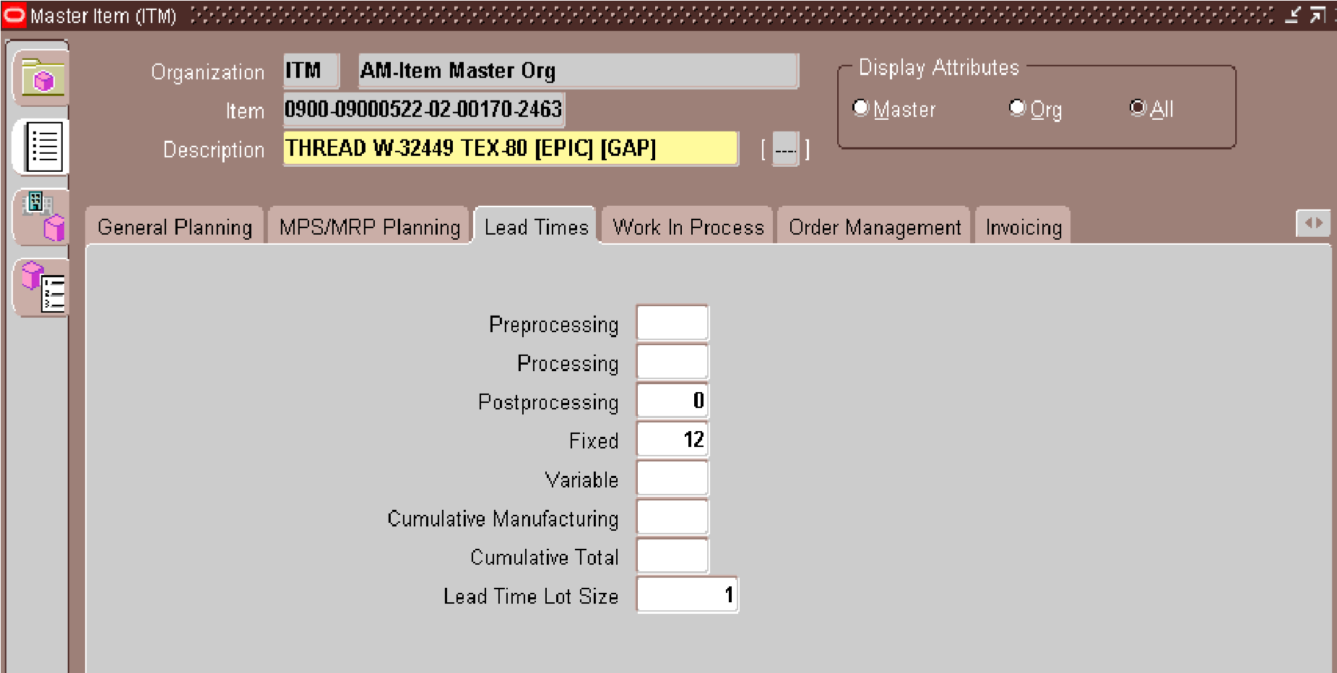
LEAD TIME WILL BE IN THE COLOUMN OF FIXED AND IT IS GIVEN BY USER
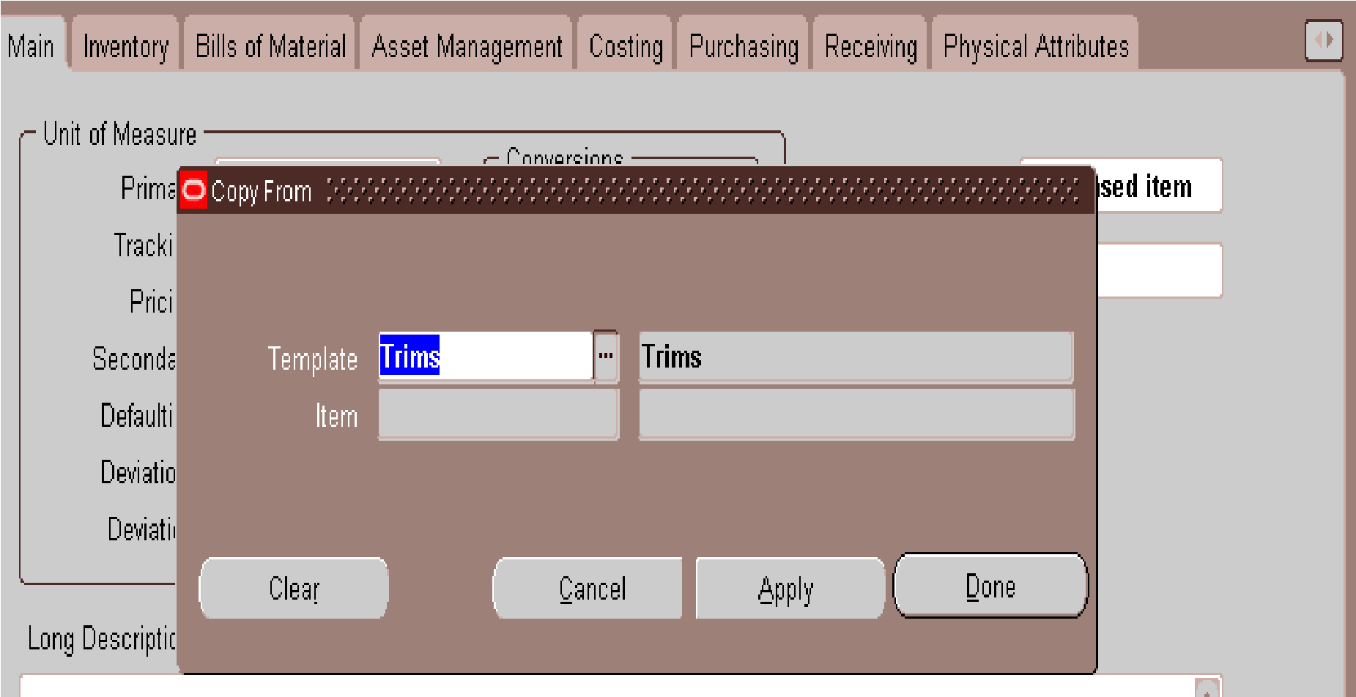
ALT+T+C FOR THE TEMPLATE FORM AND CTRL+S FOR SAVE
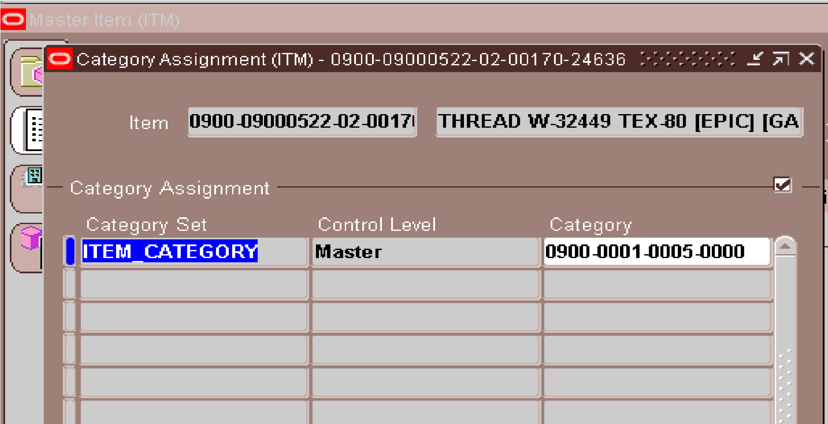
ALT+T+A FOR OPEN CATEGORY FORM
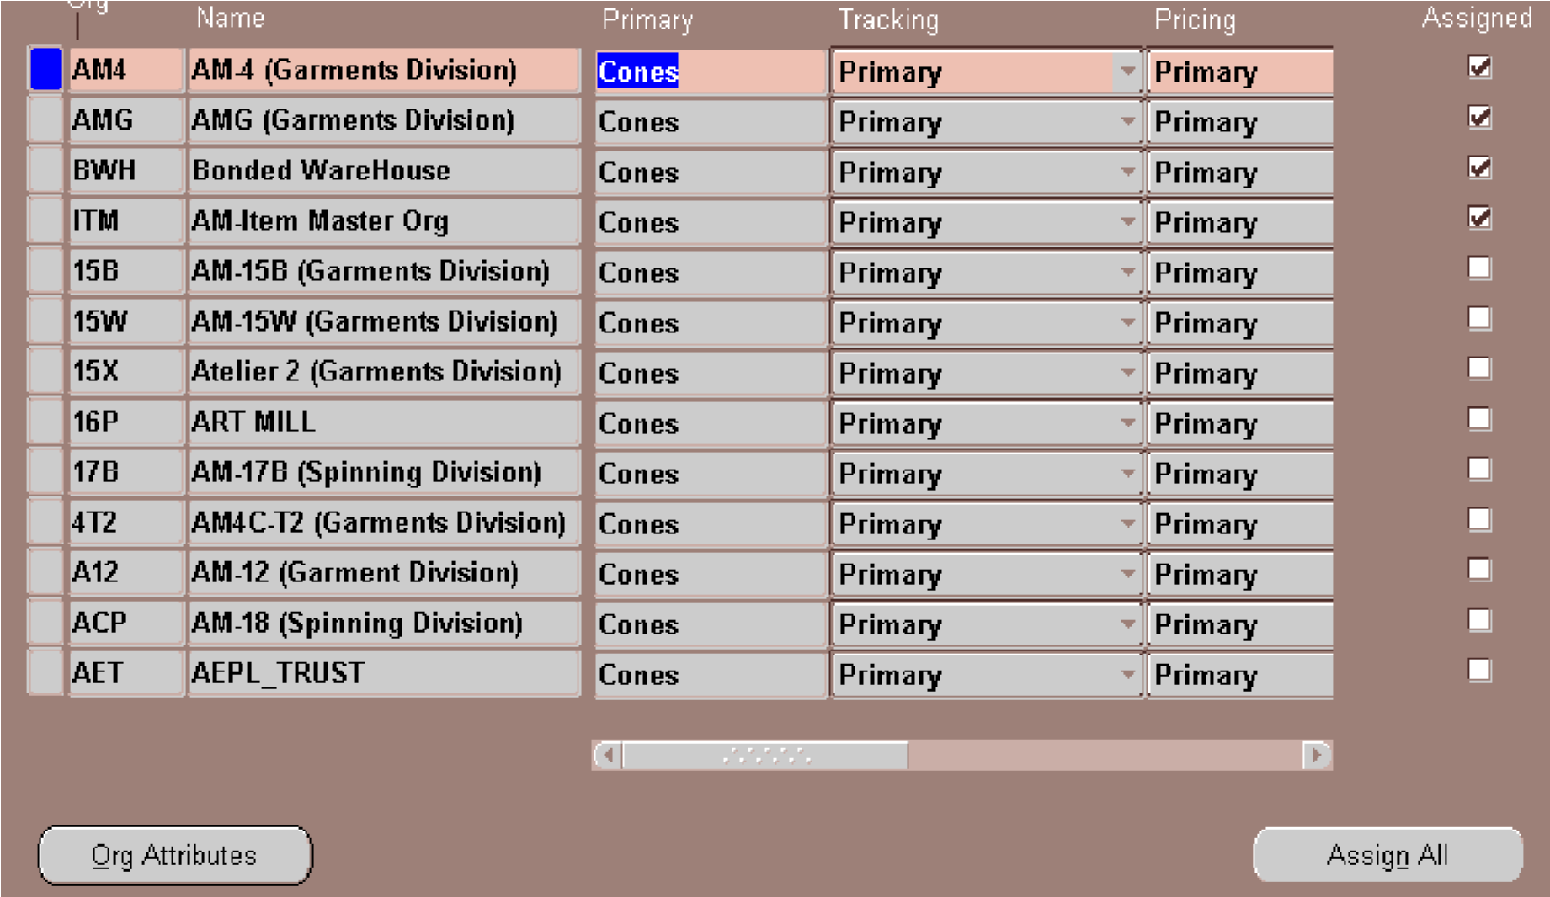
ALT+T+O FOR ASSIGN IN THE UNITS … THEN ALT+T+U FOR ITEM SUB-INVENTORIES
X____________________________________________________________________________x
UNIT ALLOCATION STEPS
1---- FIRSTLY CHECK FROM PRODUCTION MANAGER IT IS
CORRECT AND THEN OPEN IN AM4
2---- OPEN UNIT ALLOCATION
3---- COPY AM-PO CODE GIVEN BY USER
4---- CHECK STATUS
5----THEN UNIT ALLOCATE
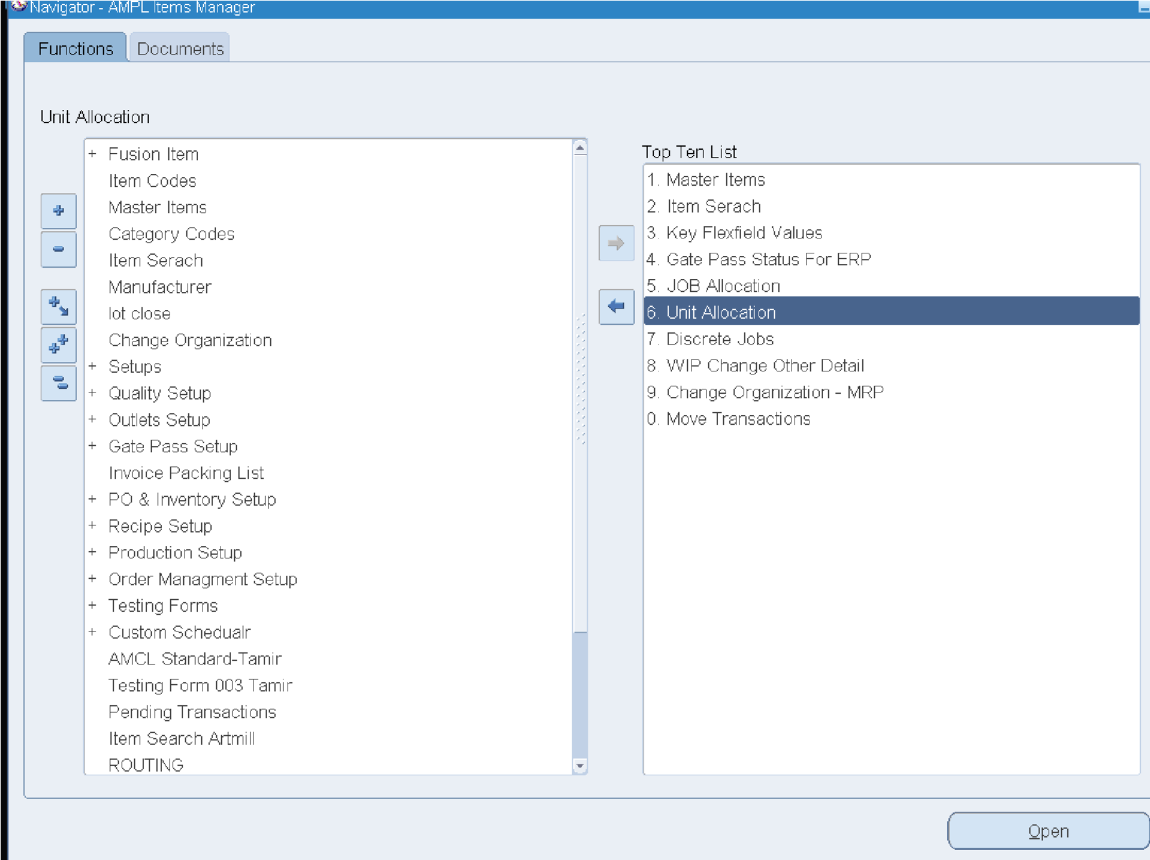
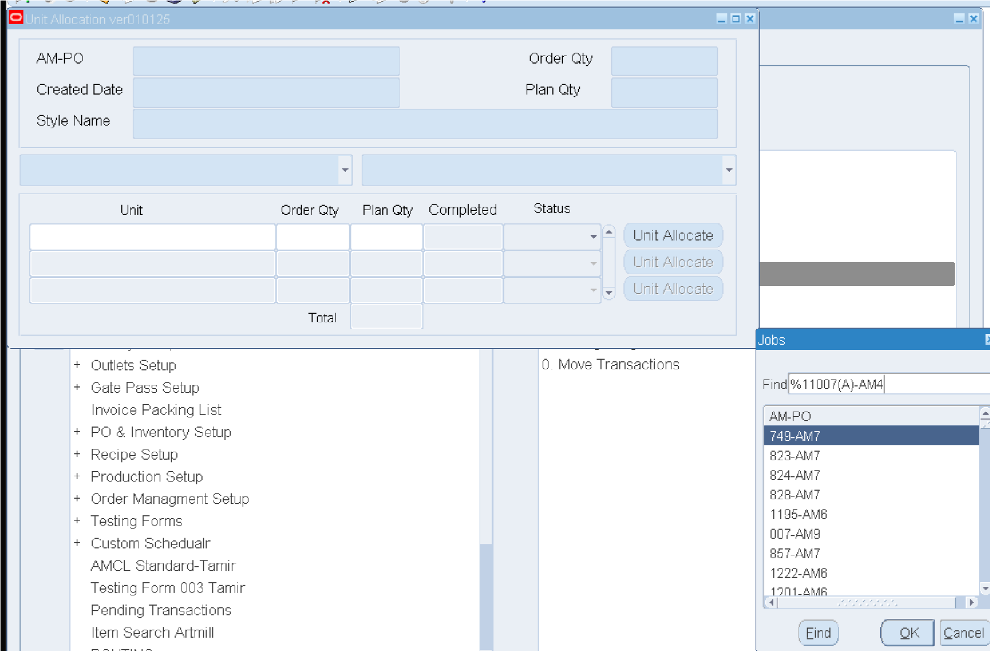
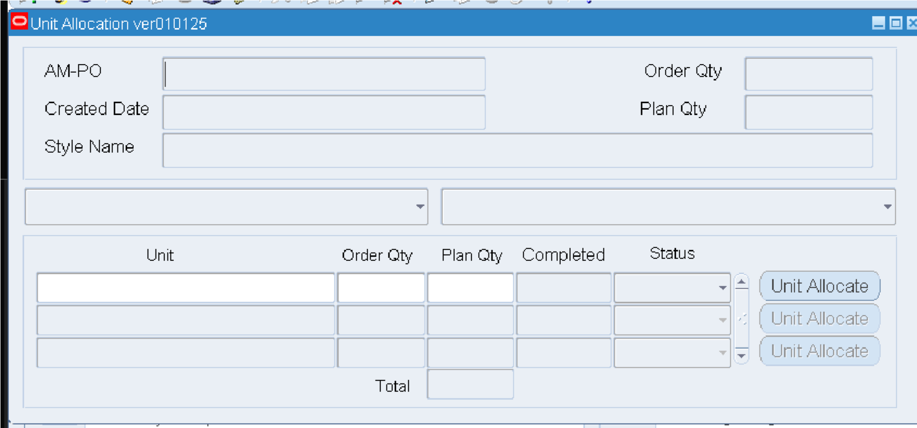
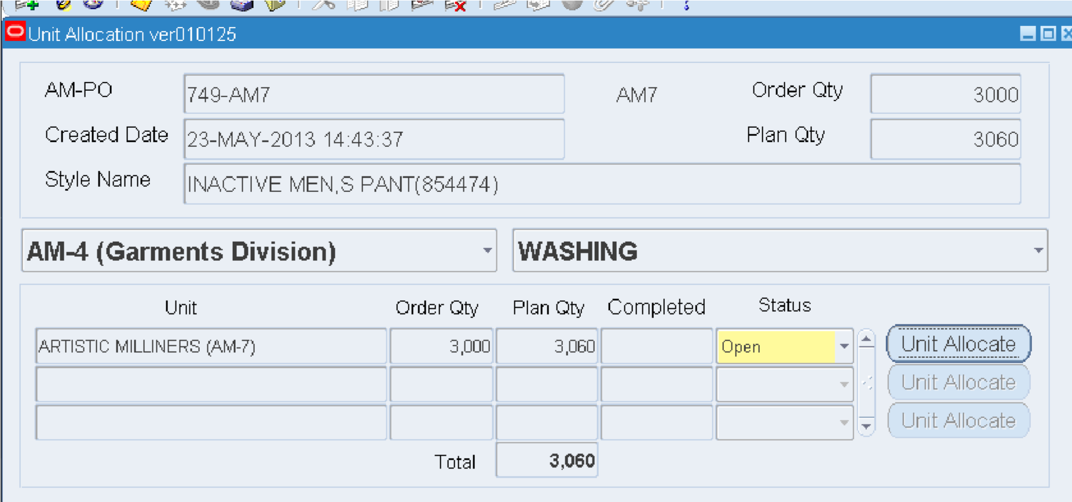
X____________________________________________________________________________x
DEMAND PROCESS :-
1) Item Code Creation :-
A new item code is created in the system according to the required category and item specifications.
- Material Requisition :- (MR )
The user submits a Material Requisition (MR) and runs the required Hierarchy.
After the MR gets approved, the system automatically generates a PR.
- Purchase Requisition :- (PR )
Once the MR is approved, a Purchase Requisition (PR) is generated to purchase the required item. 4) Rate Comparison :- (RC )
The Purchase Department prepares an RC by evaluating and comparing quotations received from different vendors.
The RC is then sent for approval and the Hierarchy is run.
- Purchase Order :- (PO )
After the RC receives all necessary approvals, the system automatically generates the Purchase Order (PO).
- Gatepass :- (GT )
A Goods Transfer (GT) is created to receive the purchased goods against the approved PO.
7) Goods Receipt Note :- (GRN )
After physically receiving and inspecting the goods, the Store Department creates the Goods Receipt Note (GRN).

